­­

##### MSc Research Thesis

##### Conceptual Design of REST-based Geospatial Web Application

**Candidate Data:**

Full Name: Rifqi Alfadhillah Sentosa

Student Number: S2793334

Email: rifqialfadhillahsentosa@student.utwente.nl

Course: M-GEO, 2022-2024

Theme: STAMP

Month, Year: November 2023

**Supervisors:**

First Supervisor: dr. J.M. Morales Guarin (j.morales@utwente.nl)

Second Supervisor: dr.ir. R.A. de By (r.a.deby@utwente.nl)

Procedural Advisor: drs. B.J. Köbben (b.j.kobben@utwente.nl)



**FACULTY OF GEO-INFORMATION SCIENCE AND EARTH OBSERVATION  
UNIVERSITY OF TWENTE, ENSCHEDE, THE NETHERLANDS**

Table of Contents

1. Research Introduction 3

1.1. Introduction 3

1.2. Research Objectives 4

1.3. Research Questions 4

1.4. Research Outline 5

2. Literature Review 6

2.1. Model Driven Architecture 6

2.1.1. Core Concepts and Components of MDA 6

2.1.2. Unified Modelling Language (UML) 8

2.2. Web Application Development 9

2.2.1. Current Practice and Trends in Web Application Development 9

2.2.2. Model Driven Development (MDD) 9

2.3. Representational State Transfer (REST) Architecture 10

2.4. OGC API Standards 11

3. Research Method 13

3.1. Domain Modeling 13

3.2. Requirement Analysis 13

3.3. UML Profile Development 14

3.4. MDA Demonstration 15

3.4.1. PIM creation 15

3.4.2. PIM to PSM transformation 15

3.4.3. PSM to Code transformation 16

3.5. Result Evaluation 16

4. RESULT 17

4.1. Domain Modeling 17

4.1.1. Geospatial Web Application Observation 18

4.1.2. Common Functions Identification 21

4.2. Requirement Analysis 24

4.2.1. Search Location 24

4.2.2. Measure Distance 25

4.2.3. Select Basemap Layer 26

4.3. UML Profile Development 27

4.3.1. Conceptual Model 27

4.3.2. PIM Profile Development 31

4.3.3. PSM Profile Development 41

4.4. MDA Demonstration (not yet structured) 52

4.4.1. PIM Instantiation (not yet structured) 53

4.4.2. PIM to PSM Transformation Development (not yet structured) 53

4.4.3. PSM to Code Transformation Development (not yet structured) 55

4.5. MDA Demonstration (not yet structured based on the user types) 55

4.5.1. XXXXXXXXXXXXXXXXXX 55

References 56

**Figure List**

Figure 1. Research method flow chart 5

Figure 2 Example of UML stereotype (Guarin, 2022) 9

Figure 3. Example illustration of PIM for spatial database (Guarin, 2022) 11

Figure 4. Example illustration of PSM for spatial database (Guarin, 2022) 12

Figure 5. Example of a simple QVT-R language syntax for transformation (Stevens, 2009) 13

**Table List**

Table 1. Study datasets 6

Table 2. Anticipated result of the research 14

Table 3. Research work plan 15

# Research Introduction

## Introduction

Web application is any software or applications that are depended on or using the World Wide Web infrastructure to be executed properly (Gellersen & Gaedke, 1999). Sophistications in this web-based innovation includes geospatial web applications that leverage geospatial information, thanks to the benefit of the global access of location-based information and services (Veenendaal, 2015). Another supportive factor is the newly updated OGC API standards by Open Geospatial Consortium, allowing the development of geospatial web application to use resource-oriented REST architecture (OGC, 2023). This new emergence aligns with the concept of REST API, one of the currently most-accepted architectural styles in web environment that allows web application specifications to be broken down into smaller and independent components, improves the application’s modularity and unlocks future interoperability and possibility to use diverse formats (Blanc et al., 2022).

Despite the sophistications and usefulness in having a geospatial web application as medium to share one’s work, developing it is not an easy task for GIS and Remote Sensing (RS) practitioners who are mostly unfamiliar with web developer roles. Software development as a field of science, including web application development, has been noted as a demanding journey in which our imaginations of sophisticated applications always exceed our ability to develop them (Barry & Lang, 2003). Traditional software development life cycle (SDLC) concepts like requirement analysis, wireframing, and testing, including methodologies like agile and waterfall model, are different sciences and require different skills to implement that are detached from what GIS/RS practitioners typically have in their repertoire.

There have been many high-level abstraction techniques that try to bridge domain-based knowledges into software development such as Model Driven Architecture (MDA) (OMG, 2014), web-based engineering including UML-based Web Engineering (UWE), Model Driven Web Engineering (MDWE) and even agile-based Mockup-Driven Development (MockupDD) (Rivero et al., 2012), which opens more possibilities for developing applications in general despite still leaving steep learning curve for the potential non-developer users. To support the sophistications in both implementations of modern geospatial web applications and the available approaches to develop one, high-level conceptual designs of what are required in developing REST-based geospatial web applications become crucial resources to enable a web application development with more approachable nature for non-developer GIS/RS users.

This research aims to define a conceptual design of modern REST-based geospatial web application and demonstrate the concept by using Model Driven Architecture (MDA) approach. MDA is an approach that helps to understand complex systems by solving the system’s complexity and interdependencies by using models (OMG, 2014). MDA initiative is a well-researched subject, with examples including Elleuch et al. (2007) and Jovanović et al. (2013) who brought Model Driven Engineering, a part of the entire OMG MDA initiative, to software architecture and user interface domain; Betari et al. (2018) modeled the computation-independent transformation; and Meliá et al. (2005) who approaches architecture modelling with MDA’s lingua franca of Unified Modelling Language (UML).

Starting from collecting varying types of existing geospatial web applications, MDA approach with its abstraction level-based separation of concern is used to capturing the common requirements into stereotypes packaged into applicable UML profile. The developed profile will be into MDA demonstration, where the profile will be used in creating an example of user-defined, Platform Independent Model (PIM) of a connected data and visualization concepts, then transformed from one abstraction level to Platform Specific Models (PSM) which led into computer code of a running geospatial web application.

Explain about the different type of users

The expected result of this research will add value to the state-of-the-art in several ways. The developed UML profile will be a well-provided concept design for non-developer, GIS/RS users and practitioners to generate standardized, REST-based geospatial web applications according to their specific requirements. This allows a geospatial web application development without the necessity of understanding most of the niche terminologies contained within the web application development. This way, individuals can seamlessly integrate geospatial property in their web applications with less time, efforts, and even the code lines itself.

## Research Objectives

The main objective of this research is to develop UML profile of stereotypes based on common requirements for REST-based geospatial web application development using Model Driven Architecture (MDA) method.

Based on the main objective, there are four sub-objectives to this research:

1. To explore how Model Driven Architecture (MDA) can represent the common requirements of REST-based geospatial web application development.
2. To develop UML stereotypes and profiles that represent the common requirements of REST-based geospatial web applications.
3. To demonstrate how the proposed UML profiles are being used in developing REST-based geospatial web application using MDA approach.
4. To evaluate the applied approach and its resulted REST-based geospatial web application.

## Research Questions

Related to the first sub-objective:

1. What is Model Driven Architecture (MDA) and its main characteristics in creating the abstraction models?
2. What is REST architectural style, and how do its characteristics can be represented in MDA models?
3. What is OGC API standard, and how do its characteristics can be represented in MDA models?

Related to the second sub-objective:

1. What are the common requirements found in geospatial web applications?
2. What are the proposed UML stereotypes that implements the common requirements of REST-based geospatial web application?
3. How do the proposed UML stereotypes be developed into UML profiles?

Related to the third sub-objective:

1. How does the proposed UML profiles support the development of the Platform Specific Model (PIM) and what are the characteristics of the developed PIM?
2. What are the transformation rules to generate Platform Specific Models (PSM) from the PIM and what are the characteristics of the developed PSMs?
3. What are the transformation rules to generate the web application code from the PSM and what are the characteristics of the generated code?

Related to the fourth sub-objective:

1. What are the characteristics of the web application developed from the MDA approach?
2. What enhancements can the generated code receive to improve the developed REST-based geospatial web application?
3. What are the current strengths and possible improvements of the proposed UML profile in the development of REST-based geospatial web application?

## Research Outline

Opening paragraph

Chapter 1 – Introduction

Chapter 2 – Literature review

Chapter 3 – Methodology

Chapter 4 – Research Result

Chapter 5 - Discussion

# Literature Review

The objective of this chapter is to provide an overview of the current and part literatures regarding the main concepts of the research. Firstly, the concept of Model Driven Architecture (MDA) approach is introduced as the main lens of the research. The definition, history and understanding of the approach will help in understanding the core topic of the research, covering from literature review to the demonstration phase.

Afterward, the subject on web application development is discussed. Knowing the definition, history, and state of the art of web application development, which overlaps with software development, is important to help in understanding the practical implication of the research in the domain of developing modern geospatial web applications. This section also brings Model Driven Development (MDD) where web application development intersects with the concept of MDA as the main lens of the research.

The literature review continues deeper into the geospatial web application niche where REST architecture and OGC API standards are introduced. REST architecture is one of the widely used architectural style in current times, especially in web environment. Its definition, history, and importance will shed light on why this particular style is popular and is chosen for this research. The key principle of REST architecture is also important to help understanding the technical aspect of the research. At last, its relation to MDA is discussed to find how REST architecture aligns with the principle of MDA and vice versa which will reflect on the result of this research.

Lastly, OGC API standards is introduced as the last concept. It is the recent sophistication in geospatial web application domain that allows geospatial web application development to follow modern trends and inspire this research to be undertaken. The definition, history, and how the standardization works help in understanding how the current standard for modern geospatial web application is. In the end, its relation to MDA is explored to see how both concepts can be implemented to each other.

## Model Driven Architecture

Model Driven Architecture (MDA) is a software designing approach to derive value and to provide guidelines for designing specifications of a software using models (OMG, 2014). It is a well-documented and guided family of standards maintained by Object Management Group (OMG) that has been a center of research and being implemented in various domains such as IT, healthcare, manufacturing, and government.

MDA promotes abstraction of complex details using high-level model to provide a structured representation of application design approach, making it easier for developer to build and understand a complex system. It highlights the use of detailed and automatically transformable models that generate executable codes of specified type of systems (Xiao & Greer, 2009). Due to its convenience and popularity, MDA has become one of the most used approaches in model-oriented software and application development.

### Core Concepts and Components of MDA

MDA contains a package of standards that cover several concerns: the abstraction models using various options of modelling languages, the model transformations, the documentations, and the model executions (OMG, 2014). MDA introduces three types of abstraction levels in modelling different viewpoints: Computer Independent Model (CIM) for expressing the working logic of an application, Platform Independent Model (PIM) for describing the information system without being tied to any platform, and lastly Platform Specific Model (PSM) for modelling the information system with more specificity using certain platforms. The models will be transformed from one level to another using defined transformation rules, with each level of transformation promotes various amount of automation.

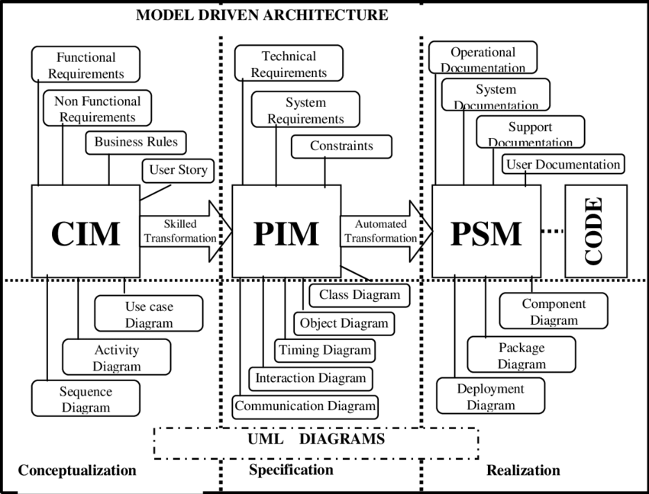

The abstraction models as core concepts of Model Driven Architecture (Singh & Sood, 2010)

Computation Independent Models (CIM) describe systems from a high-level perspective, focusing on the environment and requirements without technical details. It is commonly being referred as business model and domain model. Compared to the other abstraction models in MDA, CIM is seen as model used for analysis that helps to meet business and user requirements (Singh & Sood, 2010).

Platform Independent Models (PIM) emphasize the creation of models in which it specifications and functionalities are separated from implementations on any specific platforms. This level of abstraction disregards any kind of operating systems and programming languages (Betari et al., 2018). The use of PIM promotes technical flexibility and easier adaptation to different technologies in later abstraction (Ameller et al., 2015). PIM is seen as model used for designing the concepts of the domain (Singh & Sood, 2010).

Platform Specific Models (PSM) adopts platform-specific details to the PIM, adapting the system to a particular technological context. It details the implementation of a system including specific technologies, platforms, and frameworks, bridging the gap between the design and the actual code. PSM is seen as model used for implementation (Singh & Sood, 2010).

Model transformation is one of the main themes points of model-driven approach. By using selected model transformation, a model can be automatically transformed into another model (Thomas, 2004). In MDA context of abstraction models, the transformations define the way PIM can be transformed into PSM with the rules provided by the developer of the model transformation (OMG, 2014). MDA standardized several modeling and transformation languages from which model developers can choose from such as Design Specific Language (DSL), Query/View/Transformation (QVT), and Unified Modeling Language (UML).

In this thesis, the abstraction levels involved in the research start from PIM to PSM to direct the focus on functionality rather than higher level context of having geospatial web application, where the technical-focused level caters the target users of the research that will be elaborated more in Section XXX.

### Unified Modelling Language (UML)

UML is one of modeling languages developed by Object Management Group (OMG) that refers to the graphical models that represent properties of an object-oriented design (Duke et al., 1997). It is considered as lingua franca in software engineering (Wimmer et al., 2006). Various UML types are available for use depending on specific user goals, such as class diagram, use case diagram, and activity diagram (Shcherban et al., 2021).

UML is a widely accepted modeling language in software and web application development industry. It also adopts best practices and aligns w ell with most development frameworks in the industry, even compatible with handling RESTful web service designs (Rauf et al., 2010). The clear visual abstractions of UML, widespread adoption, and being developed and standardized by the same institution as Model Driven Architecture (MDA) adds UML dependability factor as a modeling language.

There are two separations of UML diagram types: structural and behavioral. Structural diagrams model elements in a domain to be static and true at a specific point in time (OMG, 2017) which include diagrams such as class diagram, deployment diagram, profile diagram, and component diagram (Ma & Chao, 2020). Behavioral diagram model domain elements as they change over time (OMG, 2017) which includes diagrams such as use case diagram, activity diagram, and sequence diagram (Ma & Chao, 2020). In this research, class diagram and profile diagram are heavily used alongside with the concept of UML stereotype that relates to the latter.

UML class diagram is a structural diagram that helps in designing and illustrating instances of classes in a system and relationships inside it (Gosala et al., 2021). It is commonly and heavily used as tool to model software components in a development, especially with its close relation with Object-Oriented paradigm. A class diagram typically consists of attributes (data member of the class), operations (behaviors or functions the class can perform), and relationships (how classes are connected or interact with each other) which are designed to represent elements of a system or domain.

UML profile is an extension mechanism of generic UML concepts to cater specific domain by using predefined set of stereotypes, tagged values, and constraints (Giubergia et al., 2014). Stereotype is the core of the UML profile in extending UML vocabularies, indicated as <<stereotype>> in the diagram and has same behavior as a class. While it is prohibited to modify the standardized UML and all concepts that are contained in it, this extension mechanism allows the existing UML metaclasses to be used in modeling domain-based problems without changing the original UML vocabularies.

## Web Application Development

Web application development is the action to code or program to create applications accessed though a web browser. Started as an initiative of a small number of researchers in sharing static contents, web has been intertwined with many aspects of the world (Peña-Ortiz et al., 2013) and web applications significantly responsible to that claim. The development of web applications contains many responsibilities, including the process of design, build, and maintenance. Web applications involve two concepts of technologies: frontend for visualization and user interactions; and backend for data processing and retention (Pop & Altar, 2014).

Static web applications present contents to client machine without any server-side processing, which gives faster load times but limited interactivity for the user. In contrast, dynamic web applications can provide and update contents on the fly to respond with user interactions and defined web application logics, which gives customized experience to users but may result to relatively heavier performances. Nevertheless, web applications have important place in the current world as they unlocked global accesses to many aspects of life.

### Current Practice and Trends in Web Application Development

The development of web applications has been closely mirroring those of software development methodologies. Web Development Life Cycle or WDLC (Kamatchi et al., 2013) follows Software Development Life Cycle (SDLC) techniques to in laying down the typical steps that developer teams go through in developing a web application: identifying website objectives, gathering requirements, perform the design process, test the application through multiple levels, deploy, and do maintenance.

In current industry, several development methodologies have been implemented. Waterfall model is introduced by Royce (1970) as sequence-based development process to follow through like a consecutive list of tasks to be performed to build a software, allowing straightforward ways in collecting requirement and managing team resources at the cost of low flexibility and limited end-user involvement. Agile methodology, a set of iterative and incremental approaches with high adaptability, involves sprints where short iterations are implemented to rapidly deploy parts of software to be tested. The family of Agile approaches such as Scrum and Kanban give the advantages of flexibility, collaboration, and iteration of developing software and web applications while facing challenges in documentation, high dependency to customer collaboration, and requirements for experienced developers to implement (Hossain, 2023).

For the current trends in different levels of the development, several concepts are also found to be common in software development and engineering. Design patterns attempt to apply reusable solutions to common problems in software development (Jiang & Mu, 2011) where patterns like Model-View-Controller (MVC) architectural pattern and Observer pattern are applied to make software development more structured. Lastly, popular frameworks such as React and Angular provide tools and libraries of best practices in building software and applications to enhance programming efficiency and maintainability.

### Model Driven Development (MDD)

Modeling is one of core tasks in software development, and Model Driven Engineering (MDE) become popular among developers. It leverages the concept of using models in representing applications in different levels of abstraction, and using commonly automatic, top-down model transformations to define the specificity of the previous model to other models, become ultimately deliver the final application (Rivero et al., 2012). This approach is known by several terminologies laid down by Whittle et al. (2014) including Model Driven Engineering (MDE) as the superset of MDD and Model Driven Architecture (MDA) as one of MDD instances that comply with OMG standards. Despite the interchangeable semantics of the approach, the general model driven concept is the same, and it has been proven to be beneficial to software and application development as it is a very powerful tool approach to document software architecture and eventually perform code generation, especially in domain-based companies and projects where new developments can conveniently be performed thanks to the abstraction modeling MDD proposes (Whittle et al., 2014).

Multiple software and web engineering methods apply MDD principles. Distante et al., (2007) classified this kind of web application design methods into two categories: the conceptual design-focused ones that prioritize on showing what is required for the application to perform, where approaches such as Ubiquitous Web Application (UWA) and Object-Oriented Web Solutions (OOWS) are fell into; and the logical design-focused that prioritize on showing how to implement those requirements, where a proposition from Conallen (1999) on building web application with UML is fell into. Anything in between is considered hybrid methodologies that covers both logical and conceptual designs, which includes popular methods like UML-based Web Engineering (UWE) and Web Modeling Language (WebML).

It is showcased above that MDA has been intensely studied in web application development subject and being within a larger category of the Model Driven Development. This thesis research will implement MDA in coming up with the conceptual design of developing REST-based geospatial web applications. UML as part of MDA standardized concepts is the core tool to capture the requirements that should exist in such applications. Most of the existing MDA methodologies in web application development arguably can achieve the objective of demonstrating this research. However, it is important to address that the mostly suitable target of these methods are most likely developers with enough understanding of UML and MDA to proceed, whereas this research requires to provide flatter learning curve for non-developer target users.

## Representational State Transfer (REST) Architecture

REST (Representational State Transfer) is an architectural style derived from the aggregation of several architectural style with web constraints, resulting in a style that are suitable for network-based applications (Fielding et al., 2017). It is a widely adopted approach for remote programming resources to benefit from remote APIs or services (Rodríguez et al., 2016).

The popularity comes from its core paradigm that it is a web service design that treat everything as a resource and has relatively fewer standards-compliances compared to its popular predecessor Simple Object Access Protocol (SOAP) web services, an XML-restricted protocol that has more processing times and heavier payload than REST (Malik & Kim, 2017). The governing principle of REST architectural style is based on HTTP protocol which has been fitted to web environment. The programming interfaces that follow REST architectural style are names as REST APIs.

RESTful design promotes scalability and interoperability of web services and APIs by abiding to its core principles, as laid down by Rodríguez et al., (2016):

* Resource addressability: Resources should be uniquely identified using Uniform Resource Identifier (URI).
* Resource representation: The internal structure and state of resources are kept hidden from the clients/users as they are represented only by the resource representations, XML and JSON format being the common formats, in help of HTTP protocol to manage the representations.
* Uniform interface: Resources are handled using standardized methods of HTTP protocol.
* Statelessness: Client request to the API should contain all information required to be processed, so that the server does not keep any interaction state.
* Hypermedia as the engine of state: Links between resources allow users to understand the relationships and the interaction state.

To implement REST architectural style to MDA-based web application development, it can be addressed that multiple principles between the two concepts are aligned. UML class diagram with its OO-approach is seen as fitting tool to represent REST-based web application (or to support the development of one) with its resource-based principle, where every resource can be represented as one individual class with its own attributes and possible associations and operations to apply to. REST as architectural style also capable to assume the separation of platform independence as a concept and later become technology-specific during the development of web applications.

REST architectural style also reinforces separation between server and client in an instance of web application, which also where MDA can give value with its array of options to represent static and behavioral parts of the web application system. UML-MVC model is an acknowledged approach on how both separation of concerns in applying standardized UML diagrams into MVC design pattern of web applications, which becomes a good example on how the concept of separation of concern found in both MDA and REST architectural style applies in web application development. The UML-MVC approach leverages multiple UML capabilities, namely class diagram for Model and View (combined with Controller) aspects of MVC, associations between classes, and UML sequence diagram for describing the interaction between the components and the navigation steps between View and Model classes (Distante et al., 2007).

## OGC API Standards

OGC API standards is a recently updated geospatial standards by Open Geospatial Consortium (OGC) that allows modular development for geospatial services and systems using resource-based oriented principle (OGC, 2023). Before this, the consortium was focused on maintaining OGC Web Services (OWS) since it was designed in the early 2000. It includes older version of geospatial standards such as Web Map Service (WMS) and Web Feature Service (WFS) that implement action-based Remote Procedure Call (RPC) architectural style which was indeed the state of the art during its time (OGC, 2023).

The new version of standards is the newest initiative from OGC to facilitate the adoption of the latest OpenAPI Specifications 3.0 (OAS), a programming language-agnostic described standard for HTTP API, the protocol that bases REST architectural style. This recent innovation is seen as major initiative from OGC to follow current trend in web application development and the enforcement of its family of standards toward geospatial web application will be beneficial in terms of future interoperability with modern tools, especially in promoting geospatial data integration in modern web technologies including web applications (Blanc et al., 2022).

A family of standards were introduced since 2016 such as OGC API Features, OGC API Tiles, and SensorThings API which have been supporting the use of geospatial information to follow the more sophisticated web technologies. The new family of standards adheres RESTful principle that is more lightweight and flexible than its predecessor standards. Based on its status, the standards can be categorized into two categories: Approved Standards and the ones that are not yet approved.

Approved Standards

The standards

* Explain the organization of OGC API standards by resource type.
* Emphasize the modular nature of the standards, allowing developers to choose the relevant ones for their needs.
* Approved standards; and introduce briefly.
  + OGC API – Features
  + OGC API – Common
  + OGC API - Tiles.
  + OGC API – Processes
  + OGC API – EDR
* Other standards
  + OGC API – Maps
  + OGC API – Records

Relation with MDA

* How OGC API standards align with MDA principles, particularly in terms of providing standardized interfaces for accessing geospatial data and metadata and facilitating the integration of geospatial services into model-driven workflows.
* UML and inherited (Unified Modeling Language) in capturing OGC API standards.
* How OGC API standards can be mapped to the different layers of the MDA architectural stack, including the computation-independent model (CIM), platform-independent model (PIM), and platform-specific model (PSM) layers.

# Research Method

*Everything I have done in the research*

Opening paragraph.

* The purpose of the research
  + The most important part of this research is developing a methodology …
  + The foundation of the methodology lies on …
* The purpose of this section

## Domain Modeling

Overview introduction to domain modeling

* What is domain modeling
* What are the common practice in domain modeling
* What are expected result of domain modeling
* … more citations about domain modeling

The domain modeling in this research

* The scope of analysis
* The reason why domain modeling is the best choice for this research
  + …
  + Foundation of requirement analysis
* The final result: 19 components

Detail step: Reviewing geospatial web applications

* Reviewing geospatial web applications
* Detailed steps
  + Multiple web apps are selected + reason
    - Reason to review reviewing implementation:
    - Want to capture deployed components without framework-dependency (many applications are built using a combination of different framework; therefore, it can be argued that reviewing framework may introduce framework-dependent bias in the review)
    - Practical implementation based on user-centric perspective.
  + Collecting common UI components found + reason

Detail step: Summarizing all common functions

* Summarizing all common functions
* Detailed steps:
  + Component generalization are created + reason
  + All components are categorized to the generalization + reason

## Requirement Analysis

Overview introduction to Requirement Analysis

* What is Requirement Analysis
* What are the common practice in Requirement Analysis
* What are expected result of Requirement Analysis
* … more citations about requirement analysis

The Requirement Analysis in this research

* The scope of analysis
  + Analysis is done from the lens of REST principle and OGC API standards
* The reason why Requirement Analysis is the best choice for this research
  + S
* The final result: Description of functional requirement analysis of components

Detail step: Selecting several components for representing UML profile creation

## UML Profile Development

Overview introduction to UML Profile Development

* What is UML Profile Development
* What are the common practice in UML Profile Development
* What are expected result of UML Profile Development
* … more citations about UML Profile Development

The UML Profile Development in this research

* The scope of analysis
* The reason why UML Profile Development is the best choice for this research
  + S
* The final result: UML profile for PIM and PSM

Detail step: conceptual modeling

* What is Conceptual modeling
* The scope of analysis
  + Semantics
* The reason why UML Profile Development is the best choice for this research
  + S
* The final result: Table of nouns and verbs for profile

Detail step: UML profile for PIM

* What is done in this step
* Detailed steps:
  + Separate the conceptual modeling results based on technological dependencies. Independent concepts comes to PIM.
  + Adhere MVC pattern into the PIM.
    - UML-MVC approach exist (see Distante, 2007)
    - The problem with existing studies about this:
      * Not much papers covering this topic; nothing shows example of implementation
      * Relies on UML sequence diagram, which we do not pursue to that idea.
      * Only serve developers; steep learning curve
    - This can be
  + Addressing the semantics
* The final result: UML profile for PIM

Detail step: UML profile for PSM

* What is done in this step
* Detailed steps:
  + Separate the conceptual modeling results based on technological dependencies. Independent concepts comes to PIM.
  + Adhere MVC pattern into the PIM.
  + Addressing the semantics
* The final result: UML profile for PIM

## MDA Demonstration

Overview introduction to MDA Demonstration

* What is MDA Demonstration
* What are the common practice in MDA Demonstration
* What are expected result of MDA Demonstration
* … more citations about MDA Demonstration

The MDA Demonstration in this research

* The scope of analysis
* The reason why MDA Demonstration is the best choice for this research
  + S
* The final result: Transformed web app, user-based guidance on using UML profile

### PIM creation

Overview introduction to PIM creation

* What is PIM creation
* What are the common practice in PIM creation
* What are expected result of PIM creation
* … more citations about PIM creation

The PIM creation in this research

* The scope of analysis
* The reason why PIM creation is the best choice for this research
  + S
* The final result: PIM, PIM-JSON, how to use Profile to PIM

### PIM to PSM transformation

Overview introduction to PIM to PSM transformation

* What is PIM to PSM transformation
* What are the common practice in PIM to PSM transformation
* What are expected result of PIM to PSM transformation
* … more citations about PIM to PSM transformation

The PIM to PSM transformation in this research

* The scope of analysis
* The reason why PIM to PSM transformation is the best choice for this research
  + S
* The final result: PSM, PSM-JSON, interface of proceeding & completing PSM, transformational model, script for transformation

JavaScript as transformation language

* Introduction to MDA-standardized transformation language
  + QVT, ATL, Epsilon transformation language (need citation)
  + The reason why JavaScript is chosen despite out-of-standard
    - Custom transformation logic
    - Close relation to web application context
* Javascripts’ object-oriented paradigm + Awesome JSON2JSON library
* Introduction to Object-oriented paradigm
  + The reason why this is implemented
    - UML is OOP
    - Javaascript supports, despite not the best language to do so
* Introduction to JSON2JSON library
  + The reason why this is implemented
    - Easier to handle JSON

Abstraction models (PIM, PSM) are converted into and are handled as JSON

* Introduction to JSON
  + The reason why
* Geonovum’s UML2JSON encoding
  + The reason why + benefits

### PSM to Code transformation

Overview introduction to PSM to Code transformation

* What is PSM to Code transformation
* What are the common practice in PSM to Code transformation
* What are expected result of PSM to Code transformation
* … more citations about PSM to Code transformation

The PSM to Code transformation in this research

* The scope of analysis
* The reason why PSM to Code transformation is the best choice for this research
  + S
* The final result: web app skeleton, source code, interface of proceeding & completing the source code, transformational model, script for transformation

## Result Evaluation

Not started

# RESULT

Opening paragraphs.

Outline

Introduce the three target users

* Designer
* Developer
* End-user

Designer

* Who are includes in this category
* How this thesis benefits them
* Their scope of understanding

Developer

* Who are includes in this category
* How this thesis benefits them
* Their scope of understanding

End-user

* Who are includes in this category
* How this thesis benefits them
* Their scope of understanding

(diagram) flowchart of methodology, then how each user

“In each step, appropriate user of interest will be mentioned…”

## Domain Modeling

*The final result: 19 components  
Detail step: Reviewing geospatial web* applications  
*Detail step: Summarizing all common components*

Opening paragraph of domain modeling

* User target
  + The reason why that users
  + What the user do by knowing this step
* What the step is doing
* What the purpose
* Expected final result

### Geospatial Web Application Observation

Opening paragraph of geospatial web application review

* What the step is doing
  + 6 web applications are selected
    - The reason why this 6:
      * Different use cases
      * Different data source & type (e.g. EarthExplorer for satellite imagery data; OSM and Google Map as Vector)
      * Open source & proprietary
      * Global & local perspective
  + What are done to the 6 web apps
* What the purpose
* Expected final result

#### Google Map

Opening paragraph

* What is Google Map
* What is the purpose of Google Map
* Why Google map is chosen

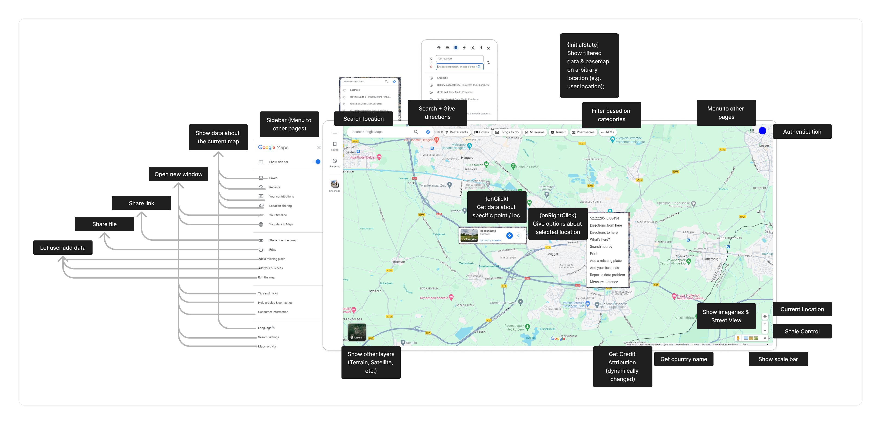Component that are found

* How many
* Explain per categorized functional requirements + reason for each

#### OpenStreetMap

Opening paragraph

* What is OpenStreetMap
* What is the purpose of OpenStreetMap
* Why OpenStreetMap is chosen

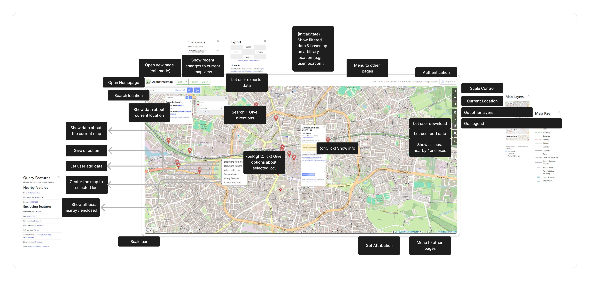Component that are found

* How many
* Explain per categorized functional requirements + reason for each

#### Earth Explorer

Opening paragraph

* What is Earth Explorer
* What is the purpose of Earth Explorer
* Why Earth Explorer is chosen

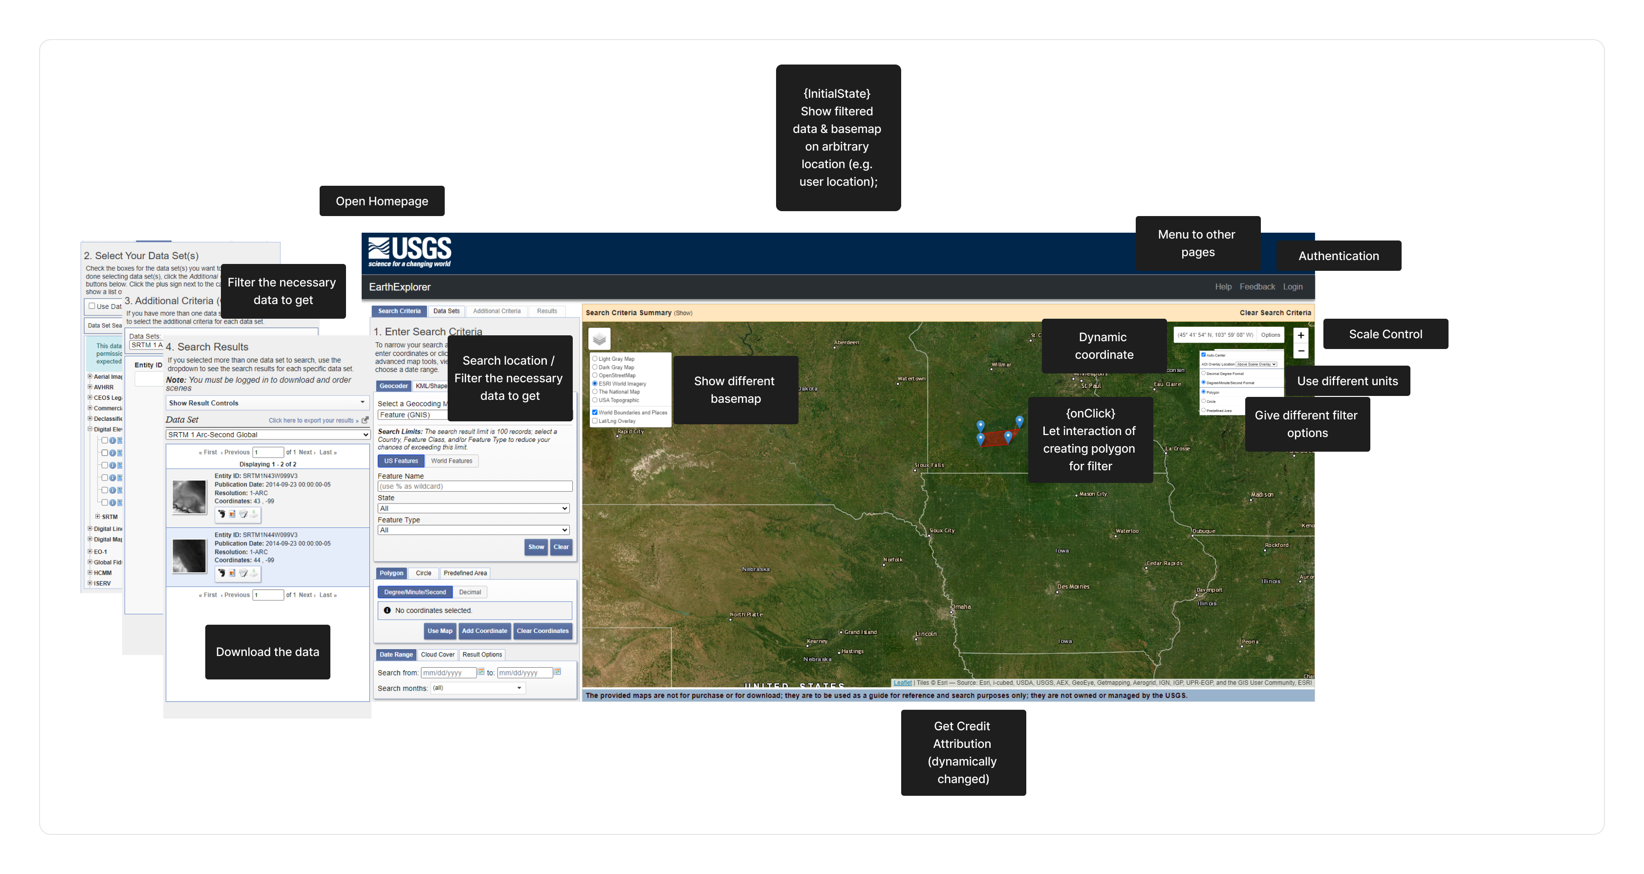Component that are found

* How many
* Explain per categorized functional requirements + reason for each

#### Samen Meten

Opening paragraph

* What is SamenMeten
* What is the purpose of SamenMeten
* Why SamenMeten is chosen

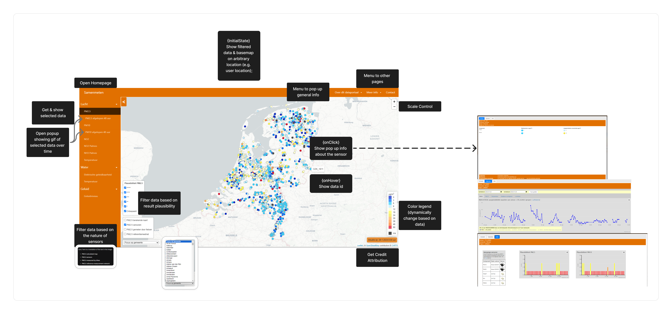Component that are found

* How many
* Explain per categorized functional requirements + reason for each

#### ShadeMap

Opening paragraph

* What is ShadeMap
* What is the purpose of ShadeMap
* Why ShadeMap is chosen

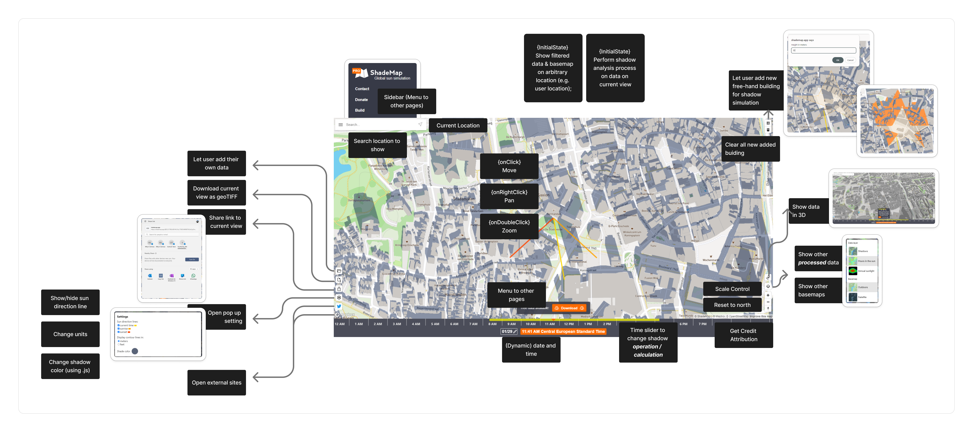Component that are found

* How many
* Explain per categorized functional requirements + reason for each

#### PDOK

Opening paragraph

* What is PDOK
* What is the purpose of PDOK
* Why PDOK is chosen

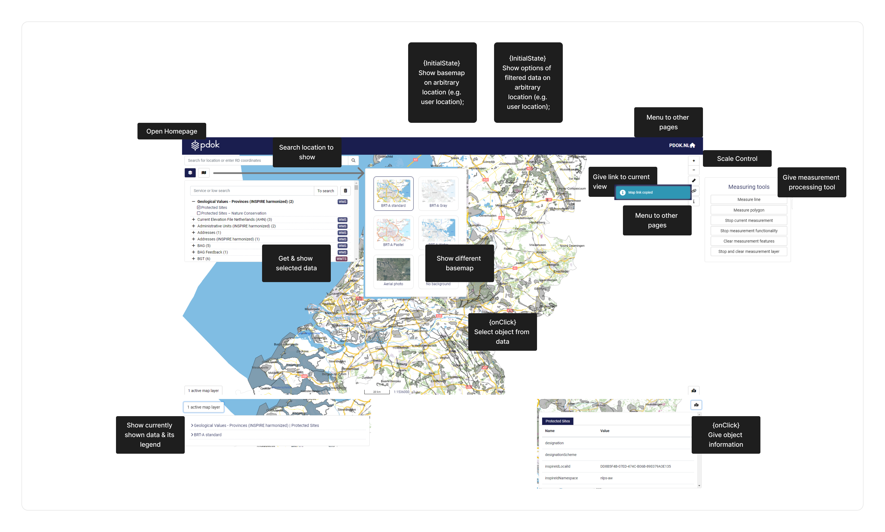Component that are found

* How many
* Explain per categorized functional requirements + reason for each

### Common Functions Identification

Opening paragraph of Common Functions Identification

* What the step is doing
  + Simply summarizing the common functions
* What the purpose
* Expected final result

Common functions:

1. Perform processes.
2. Open Other Resources.
3. Authentication.
4. Attribution.
5. Get Other Layer.
6. Initialization.
7. Filter Data to Show.
8. Show user's current location.
9. Scale control.
10. Scale bar.
11. Get info about selected location.
12. Let User Add Data.
13. Share Link.
14. Download Data.
15. Add Legend.
16. Custom right-click.
17. Use different units.
18. Change style.
19. Interact with currently shown view.
20. Move or orient current view.

(Table form)



Selecting 3 functions

* What the step is doing
  + Selecting the 3 components to be detailed
    - Reason for why these three: covers ranges of possible web app logics
      * Processes
      * Interactivity between components
      * Frontend-backend-data connections
    - Reason why
* What the purpose
  + For requirement analysis

## Requirement Analysis

*Detail step: Selecting several components for representing UML profile creation*

Opening paragraph of requirement analysis

* User target
  + The reason why those users
  + What the users do by knowing this step
* What the step is doing
  + The selected 3 functions are analyzed
    - Analysis is done from the lens of REST principle and OGC API standards
  + Describing the sequence of actions and interactions between the user, front-end, and back-end components
* What the purpose
  + crucial for creating a comprehensive and accurate UML profile that reflects the actual behaviors and interactions within the web application, for the selected components.
* Expected final result
  + Descriptive form of functional requirements

### Search Location

Opening paragraph

* How common is this function in web application
  + Common UI components involved in this function.
* Why chosen: showcasing frontend-backend-data connections

Functional requirements

1. The user enters a location-based query into the search bar. It could take various forms:
   * Keyword search: the name of a place e.g. city.
   * Spatial search: a specific coordinate or a bounding box.
2. The user initiates the search by pressing "Enter" or clicking a search button.
3. The front-end code constructs an HTTP GET request with appropriate query parameters.
4. The backend server parses the HTTP request to extract relevant information from the query parameters.
5. The request is routed to the specific geospatial module or service within the backend, such as a geospatial search service or a geocoding service.
6. The geospatial module or service executes the necessary operations based on the type of geospatial search requested.
7. Geospatial services may interact with the geospatial data source to retrieve relevant information.
8. Once the data is retrieved, the backend performs additional processing, such as transforming the raw data into GeoJSON format.
9. The geospatial service generates the HTTP response in a standardized format (e.g. GeoJSON) and sends it back to the front end using standard parsing libraries compatible with GeoJSON.
10. The front end parses the HTTP response to extract the relevant information.
11. The front end processes the retrieved information to update the user interface with the search results.

Summary

* Summary the list as a short paragraph.

How the functional requirements comply with everything.

* How it complies with REST architecture principle.
* How it complies with OGC API Standards + OpenAPI specifications

### Measure Distance

Opening paragraph

* How common is this function in web application.
  + Common UI components involved in this function.
* Why chosen: showcasing how to perform processes.

Functional requirements:

1. The user initiates a distance measurement process by interacting with provided interface.
2. The user selects two points on the map for distance measurement. Event listener attached to the interface detects this interaction.
3. The frontend sends a POST request to the backend server to initiate the distance measurement. The request contains a JSON payload with the selected points and measurement parameters.
4. The backend server parses the HTTP request to extract relevant information. The server validates the input data.
5. The backend creates a job resource to handle the distance measurement task. A unique identifier is assigned to the job. The server responds with a 202 Accepted status and a URL to poll for job status.
6. The distance measurement is performed by the appropriate module or service.
7. The frontend periodically checks the status of the job by sending a GET request to the job URL.
8. When the distance measurement is complete, the backend updates the job resource with the result.
9. The frontend updates the user interface to display the measured distance.

Summary

* Summary the list as a short paragraph.

How the functional requirements comply with everything.

* How it complies with REST architecture principle.
* How it complies with OGC API Standards + OpenAPI specifications

### Select Basemap Layer

Opening paragraph

* How common is this function in web application.
  + Common UI components involved in this function.
* Why chosen: showcasing the interaction between components.

Technical requirements:

1. During the initialization of map visualization in the application, a section of the UI provides an option list or dropdown menu for selecting basemap layers. The frontend sends an HTTP GET request to the backend for metadata of the available basemap layers and displays the response in a dedicated section.
2. en a user selects a basemap layer from the dropdown, the frontend sends an HTTP GET request to the backend, specifying the selected basemap layer.
3. The backend parses the HTTP request and fetches the data associated with the selected basemap layer.
4. The backend sends the requested data (or alternatively tiles) back to the frontend by generating HTTP 200 response.
5. The frontend parses the HTTP response to retrieve the data or tiles from the backend.
6. The frontend updates the map, replacing the current basemap layer with the newly selected one. If the backend provided raw data, the frontend might need to render the basemap layer.
7. The user can interact with the map, such as panning or zooming. The frontend sends additional GET requests to the backend for tiles covering the newly visible area.

Summary

* Summary the list as a short paragraph.

How the functional requirements comply with everything.

* How it complies with REST architecture principle.
* How it complies with OGC API Standards + OpenAPI specifications

## UML Profile Development

*Detail step: conceptual modeling*

*Detail step: UML profile for PIM*

*Detail step: UML profile for PSM*

This section explains the development of UML profile following the technical analyses resulted from the previous requirement analysis phase. This section is targeted appropriately for *Developer* user type of this thesis only, since this phase is still included in development of the approach. By knowing and applying this phase, the targeted user will understand the proposed approach to build the UML profile that both capture the conceptual model of REST-based geospatial web application in multiple level of abstractions and will be used practically for the implementation in developing the REST-based geospatial web application using MDA approach.

This phase continues the detailed technical analyses from the previous requirement analysis step which has included the observed REST-based geospatial web application components, the concept of REST architecture and OGC API standards inside it. The purpose of taking this phase is to develop two UML profiles with contained stereotypes to provide the two MDA level of abstractions: Platform Independent Model (PIM) and Platform Specific Model (PSM). This phase translates the preceding analyses phases to the designing phase and lead to the implementation of every concepts that has been captured. The final result of this phase will be UML profile for developing PIM and PSM.

This phase explains in detail the steps contained to achieve the final result, namely the conceptual modeling process of the functional requirements, the development of PIM and PSM profile using the conceptualized model, and the model transformations to connect both abstractions model to generate code that later becomes the source code of a developed REST-based geospatial web application.

### Conceptual Model

This step conceptualized the three analyzed functional requirements using UML class concept. Since REST principle and OGC API standards have been applied as the lens in analyzing the functional requirements, the UML classes resulted from this step should capture the requirements that allow development of REST-based geospatial web application that abide with the principle and standards. This step bridges the gap between analysis step to designing step of this research.

First, the step summarized all nouns and verbs contained from the functional requirements. *(… Why nouns and verbs approach is used. Nouns for potential class and attribute name, verbs for potential operations and association. Citation might be needed …)*. The items captured in the summary table is then observed on whether it can be potential UML class, attribute, operation, or association. Table XXX shows the summary of all nouns and verbs.

The first noun to be captured is *user*. This semantic is captured from all three functional requirements as *user* should be present to interact with the geospatial web application. The user is closely related to all interactions with geospatial web application. Since user will be interacting with all elements in a geospatial web application and “designing the user” is not an appropriate perspective during designing the components of geospatial web application, it is decided to put more emphasis on *user interaction* to represent the *user* element that is closely coherent with the components which allow appropriate designing process.

Multiple verbs that relate to *user* are as follow:

* *Enter*. This verb represents the possible event when a user *enters* some inputs to the geospatial web application using provided UI component, such as entering location query using search bar.
* Initiate. This verb represents …
* Press. …
* Click. …
* Interact. …
* Select. …

The next noun is …

(table is below, should be moved up) Table of nouns and verbs as a step of conceptual modeling



Based on the analysis and considerations to each items in the summary table, several classes are generated as shown in Figure XXX. The classes are intentionally structured in three separate columns to apply MVC design pattern. *(… Introduction to MVC pattern. Why MVC is chosen and benefits of applying it to this step. Citation might be needed …)*. The UML classes resulted in this phase are not using many UML capabilities such as multiplicity and associations, which will be applied during the development of UML profile.

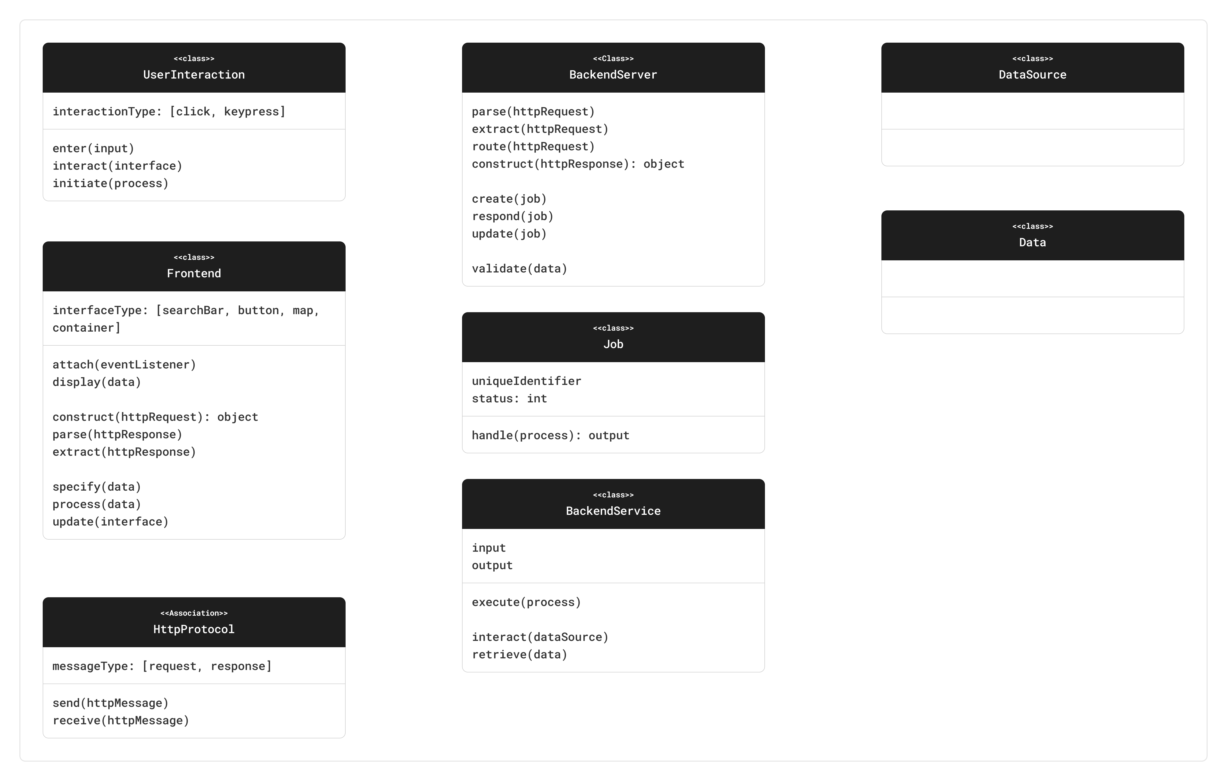

The class *UserInteraction* represents interactions that are captured from the functional requirements. It covers all possible interactions a user might perform with a geospatial web application. The attribute *interactionType* provide the mean to specify what kind of interaction a user perform in any arbitrary instance of this class, examples from the functional requirements are *click* to represent any kind of mouse clicks and *keypress* to represent any kind of keyboard presses. The operation enter represents the possibility of a user to enter an input to geospatial web application. The operation *interact* represent the possibility of a user to interact with UI elements of geospatial web application and perform any interaction types that are defined in the *interactionType* attribute. The operation *initiate* represents the possibility of a user to perform a process by interacting with provided UI component in the geospatial web application interface.

The class *Frontend* represents …

Additional reasoning behind the UML classes

* Why some are generalized + example
* Why some are ditched + example

PIM and PSM profile separation

* Which classes come to PIM profile
  + Reason why:
    - Platform independent
    - Focus on users’ limited concern in building PIM
* Which classes come to PSM profile
  + Reason why
    - Platform dependent
    - Focus on users’ limited concern in building PIM

### PIM Profile Development

Opening paragraph of PIM profile development

* What the step is doing
  + Expanding the conceptual UML model into usable UML profile
* What the purpose
* Briefly introduce potential use of this to all targeted users
  + Which will be detailed in later demonstration section

Introducing the diagram below:

* What we are seeing in the diagram
  + What is <<pkg>>
  + What is <<profile>>
  + What is the arrow

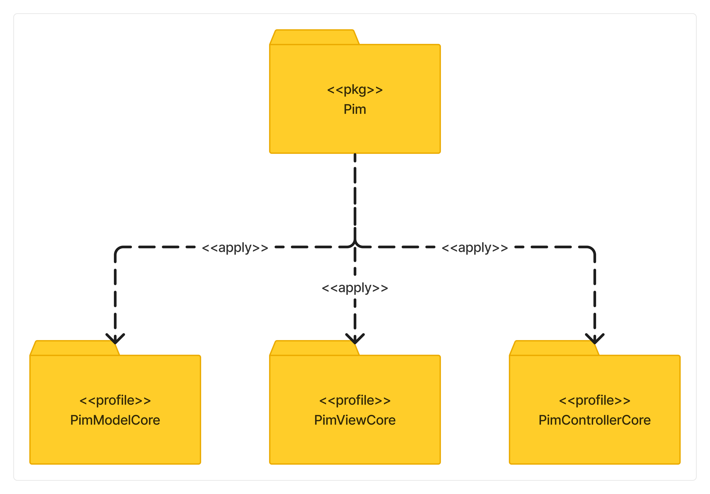

What should be the PIM profile looks like

* Splitting and expanding the conceptual model result
  + What are the class for PIM profile.
    - The reason why they are chosen to be included in PIM profile.
* MVC separated profile.
  + Continuing the separation of concern
  + Class + Association relationship
    - Helping the connection between classes within and across profile
* Briefly introduce the explanatory subsections below

#### PIM MVC-Model Profile

*Only exclusively talk about why the profile being made like this; not how to use it. For that part, there will be a separate section about it*

Opening paragraph of PIM MVC-Model

* What is this profile.
* The purpose of having this profile
* The brief introduction of what is inside this profile.



Overview explanation

* What is inside this profile
  + Classes
  + Associations
* The reason why

Explanation – Dataset class

* What is it.
  + Definition
  + The reason why it is like that.
* The reason is it present here.
* The reason why it inherits a certain parent class if any
* Attributes
  + The reason why it is like that.
* Operations
  + The reason why it is like that.

Explanation – Spatial Dataset class

* What is it.
  + Definition
  + The reason why it is like that.
* The reason is it present here.
* The reason why it inherits a certain parent class if any
* Attributes
  + The reason why it is like that.
* Operations
  + The reason why it is like that.

Explanation – Vector Dataset class

* What is it.
  + Definition
  + The reason why it is like that.
* The reason is it present here.
* The reason why it inherits a certain parent class if any
* Attributes
  + The reason why it is like that.
* Operations
  + The reason why it is like that.

Explanation – Raster Dataset class

* What is it.
  + Definition
  + The reason why it is like that.
* The reason is it present here.
* The reason why it inherits a certain parent class if any
* Attributes
  + The reason why it is like that.
* Operations
  + The reason why it is like that.

Explanation – Non Spatial Dataset class

* What is it.
  + Definition
  + The reason why it is like that.
* The reason is it present here.
* The reason why it inherits a certain parent class if any
* Attributes
  + The reason why it is like that.
* Operations
  + The reason why it is like that.

Explanation – Data Service

Explanation – Spatial Data Service

Explanation – Web Feature Service

Explanation – Web Map Service

Explanation – Vector Tile Service

Explanation – Raster Tile Service

Explanation – Non Spatial Data Service

Explanation – Data Store

Explanation – Local Data Store

Explanation – Cloud Data Store

Explanation – Offer association

Explanation – Display association

Explanation – Process association

#### PIM MVC-View Profile

*Only exclusively talk about why the profile being made like this; not how to use it. For that part, there will be a separate section about it*

Opening paragraph of PIM MVC-View

* What is this profile
* The purpose of having this profile
* The brief introduction of what is inside this profile

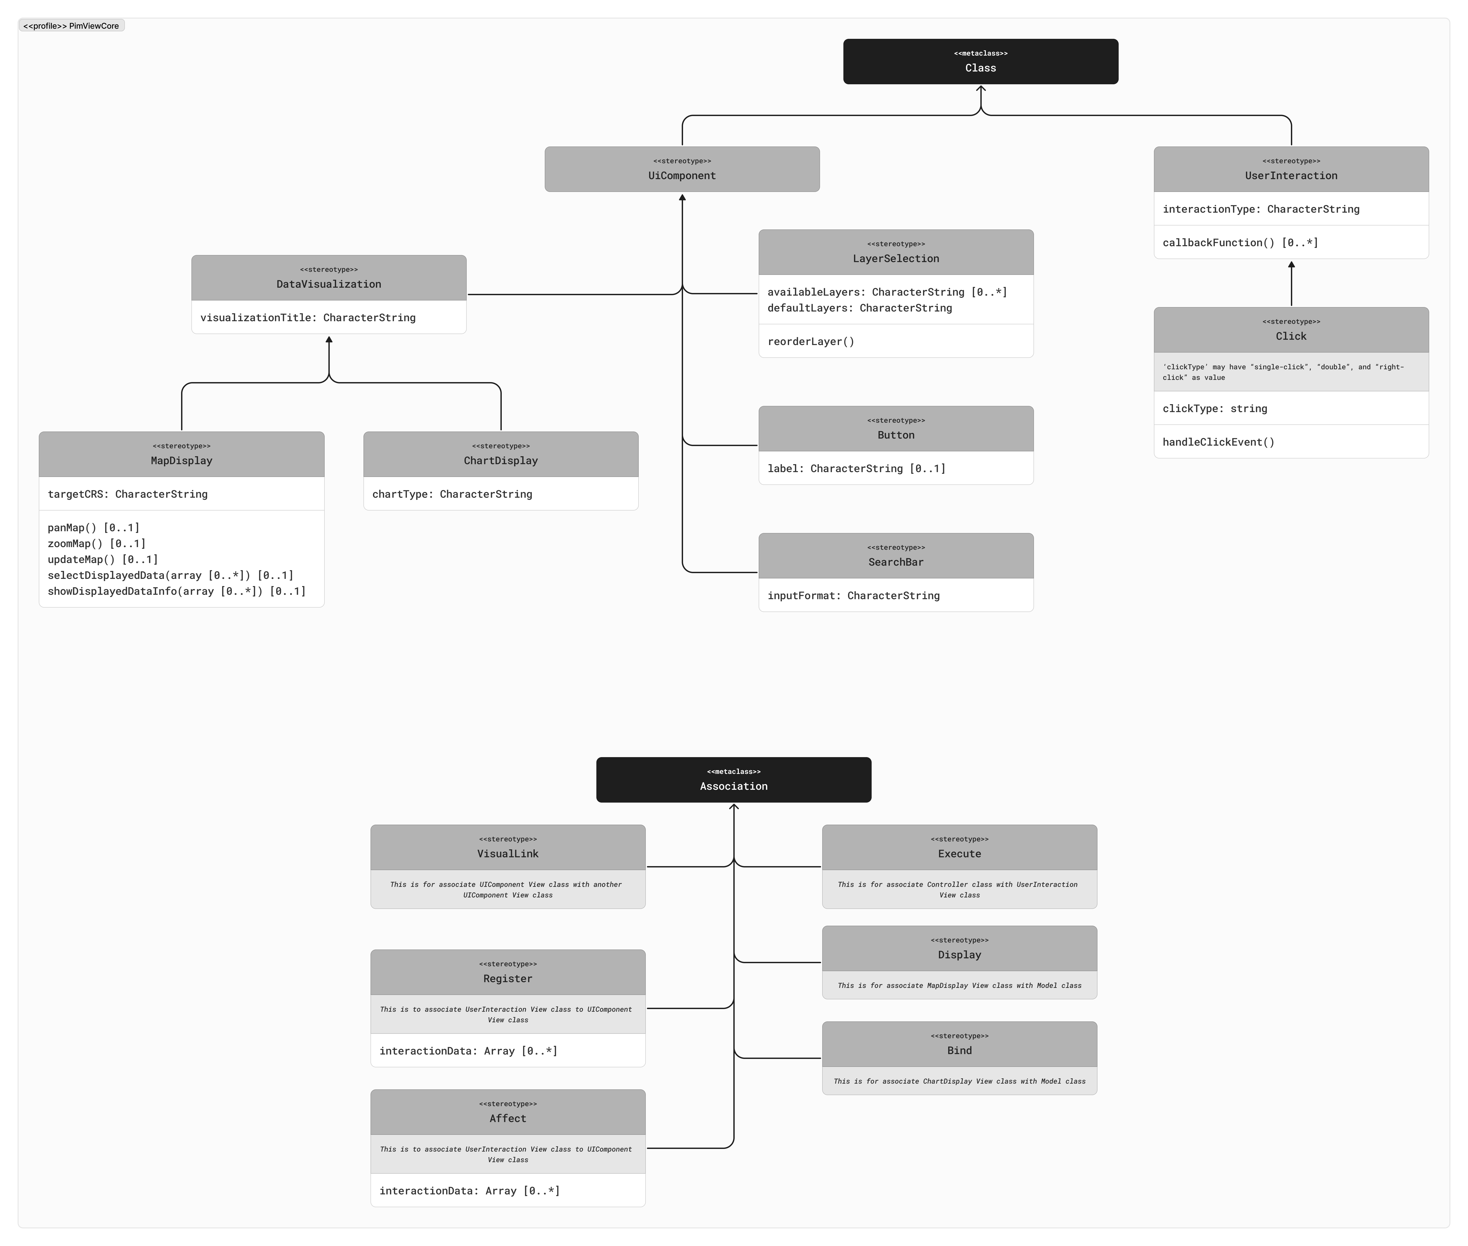

Overview explanation

* What is inside this profile
  + Classes
  + Associations
* The reason why

Explanation – UI component

* What is it.
  + Definition
  + The reason why it is like that.
* The reason is it present here.
* The reason why it inherits a certain parent class if any
* Attributes
  + The reason why it is like that.
* Operations
  + The reason why it is like that.

Explanation – Data Visualization

* What is it.
  + Definition
  + The reason why it is like that.
* The reason is it present here.
* The reason why it inherits a certain parent class if any
* Attributes
  + The reason why it is like that.
* Operations
  + The reason why it is like that.

Explanation – Map Display

* What is it.
  + Definition
  + The reason why it is like that.
* The reason is it present here.
* The reason why it inherits a certain parent class if any
* Attributes
  + The reason why it is like that.
* Operations
  + The reason why it is like that.

Explanation – Chart Display

* What is it.
  + Definition
  + The reason why it is like that.
* The reason is it present here.
* The reason why it inherits a certain parent class if any
* Attributes
  + The reason why it is like that.
* Operations
  + The reason why it is like that.

Explanation – Layer Selection

* What is it.
  + Definition
  + The reason why it is like that.
* The reason is it present here.
* The reason why it inherits a certain parent class if any
* Attributes
  + The reason why it is like that.
* Operations
  + The reason why it is like that.

Explanation – Button

* What is it.
  + Definition
  + The reason why it is like that.
* The reason is it present here.
* The reason why it inherits a certain parent class if any
* Attributes
  + The reason why it is like that.
* Operations
  + The reason why it is like that.

Explanation – Search Bar

* What is it.
  + Definition
  + The reason why it is like that.
* The reason is it present here.
* The reason why it inherits a certain parent class if any
* Attributes
  + The reason why it is like that.
* Operations
  + The reason why it is like that.

Explanation – Visual Link

* What is it.
  + Definition
  + The reason why it is like that.
* The reason is it present here.
* The reason why it inherits a certain parent class if any
* Attributes
  + The reason why it is like that.
* Operations
  + The reason why it is like that.

Explanation – Register

* What is it.
  + Definition
  + The reason why it is like that.
* The reason is it present here.
* The reason why it inherits a certain parent class if any
* Attributes
  + The reason why it is like that.
* Operations
  + The reason why it is like that.

Explanation – Affect

* What is it.
  + Definition
  + The reason why it is like that.
* The reason is it present here.
* The reason why it inherits a certain parent class if any
* Attributes
  + The reason why it is like that.
* Operations
  + The reason why it is like that.

Explanation – Execute

* What is it.
  + Definition
  + The reason why it is like that.
* The reason is it present here.
* The reason why it inherits a certain parent class if any
* Attributes
  + The reason why it is like that.
* Operations
  + The reason why it is like that.

Explanation – Display

* What is it.
  + Definition
  + The reason why it is like that.
* The reason is it present here.
* The reason why it inherits a certain parent class if any
* Attributes
  + The reason why it is like that.
* Operations
  + The reason why it is like that.

Explanation – Bind

* What is it.
  + Definition
  + The reason why it is like that.
* The reason is it present here.
* The reason why it inherits a certain parent class if any
* Attributes
  + The reason why it is like that.
* Operations
  + The reason why it is like that.

#### PIM MVC-Controller Profile

*Only exclusively talk about why the profile being made like this; not how to use it. For that part, there will be a separate section about it*

Opening paragraph of PIM MVC-Controller

* What is this profile
* The purpose of having this profile
* The brief introduction of what is inside this profile

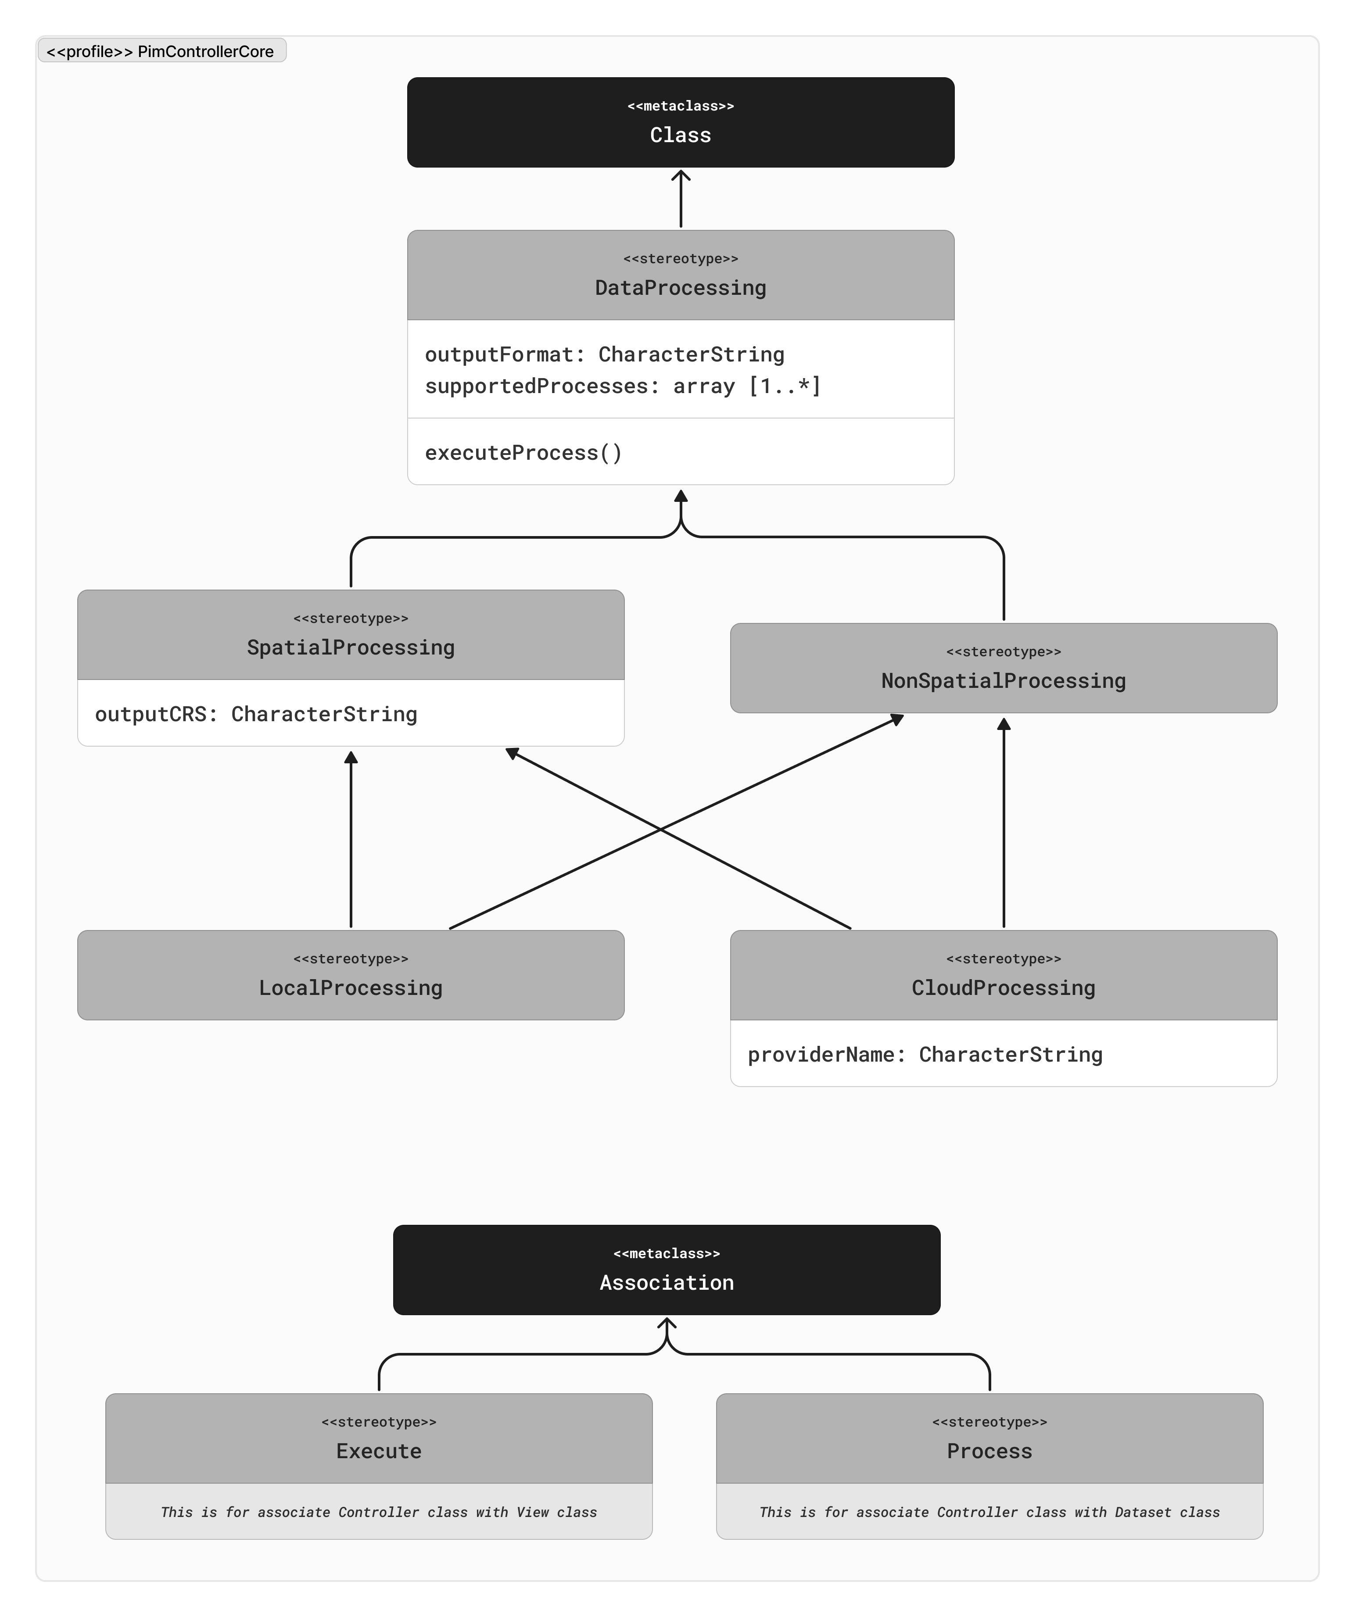

Overview explanation

* What is inside this profile
  + Classes
  + Associations
* The reason why

Explanation – Data Processing

* What is it.
  + Definition
  + The reason why it is like that.
* The reason is it present here.
* The reason why it inherits a certain parent class if any
* Attributes
  + The reason why it is like that.
* Operations
  + The reason why it is like that.

Explanation – Spatial Processing

* What is it.
  + Definition
  + The reason why it is like that.
* The reason is it present here.
* The reason why it inherits a certain parent class if any
* Attributes
  + The reason why it is like that.
* Operations
  + The reason why it is like that.

Explanation – Non Spatial Processing

* What is it.
  + Definition
  + The reason why it is like that.
* The reason is it present here.
* The reason why it inherits a certain parent class if any
* Attributes
  + The reason why it is like that.
* Operations
  + The reason why it is like that.

Explanation – Local Processing

* What is it.
  + Definition
  + The reason why it is like that.
* The reason is it present here.
* The reason why it inherits a certain parent class if any
* Attributes
  + The reason why it is like that.
* Operations
  + The reason why it is like that.

Explanation – Clod Processing

* What is it.
  + Definition
  + The reason why it is like that.
* The reason is it present here.
* The reason why it inherits a certain parent class if any
* Attributes
  + The reason why it is like that.
* Operations
  + The reason why it is like that.

Explanation – Execute association

* What is it.
  + Definition
  + The reason why it is like that.
* The reason is it present here.
* The reason why it inherits a certain parent class if any
* Attributes
  + The reason why it is like that.
* Operations
  + The reason why it is like that.

Explanation – Process association

* What is it.
  + Definition
  + The reason why it is like that.
* The reason is it present here.
* The reason why it inherits a certain parent class if any
* Attributes
  + The reason why it is like that.
* Operations
  + The reason why it is like that.

### PSM Profile Development

Opening paragraph of PSM profile development

* What the step is doing
  + Expanding the conceptual UML model into usable UML profile
* What the purpose
* Briefly introduce potential use of this to all targeted users
  + Which will be detailed in later demonstration section

Introducing the diagram below:

* What we are seeing in the diagram
  + What is <<pkg>>
  + What is <<profile>>
  + What is the arrow

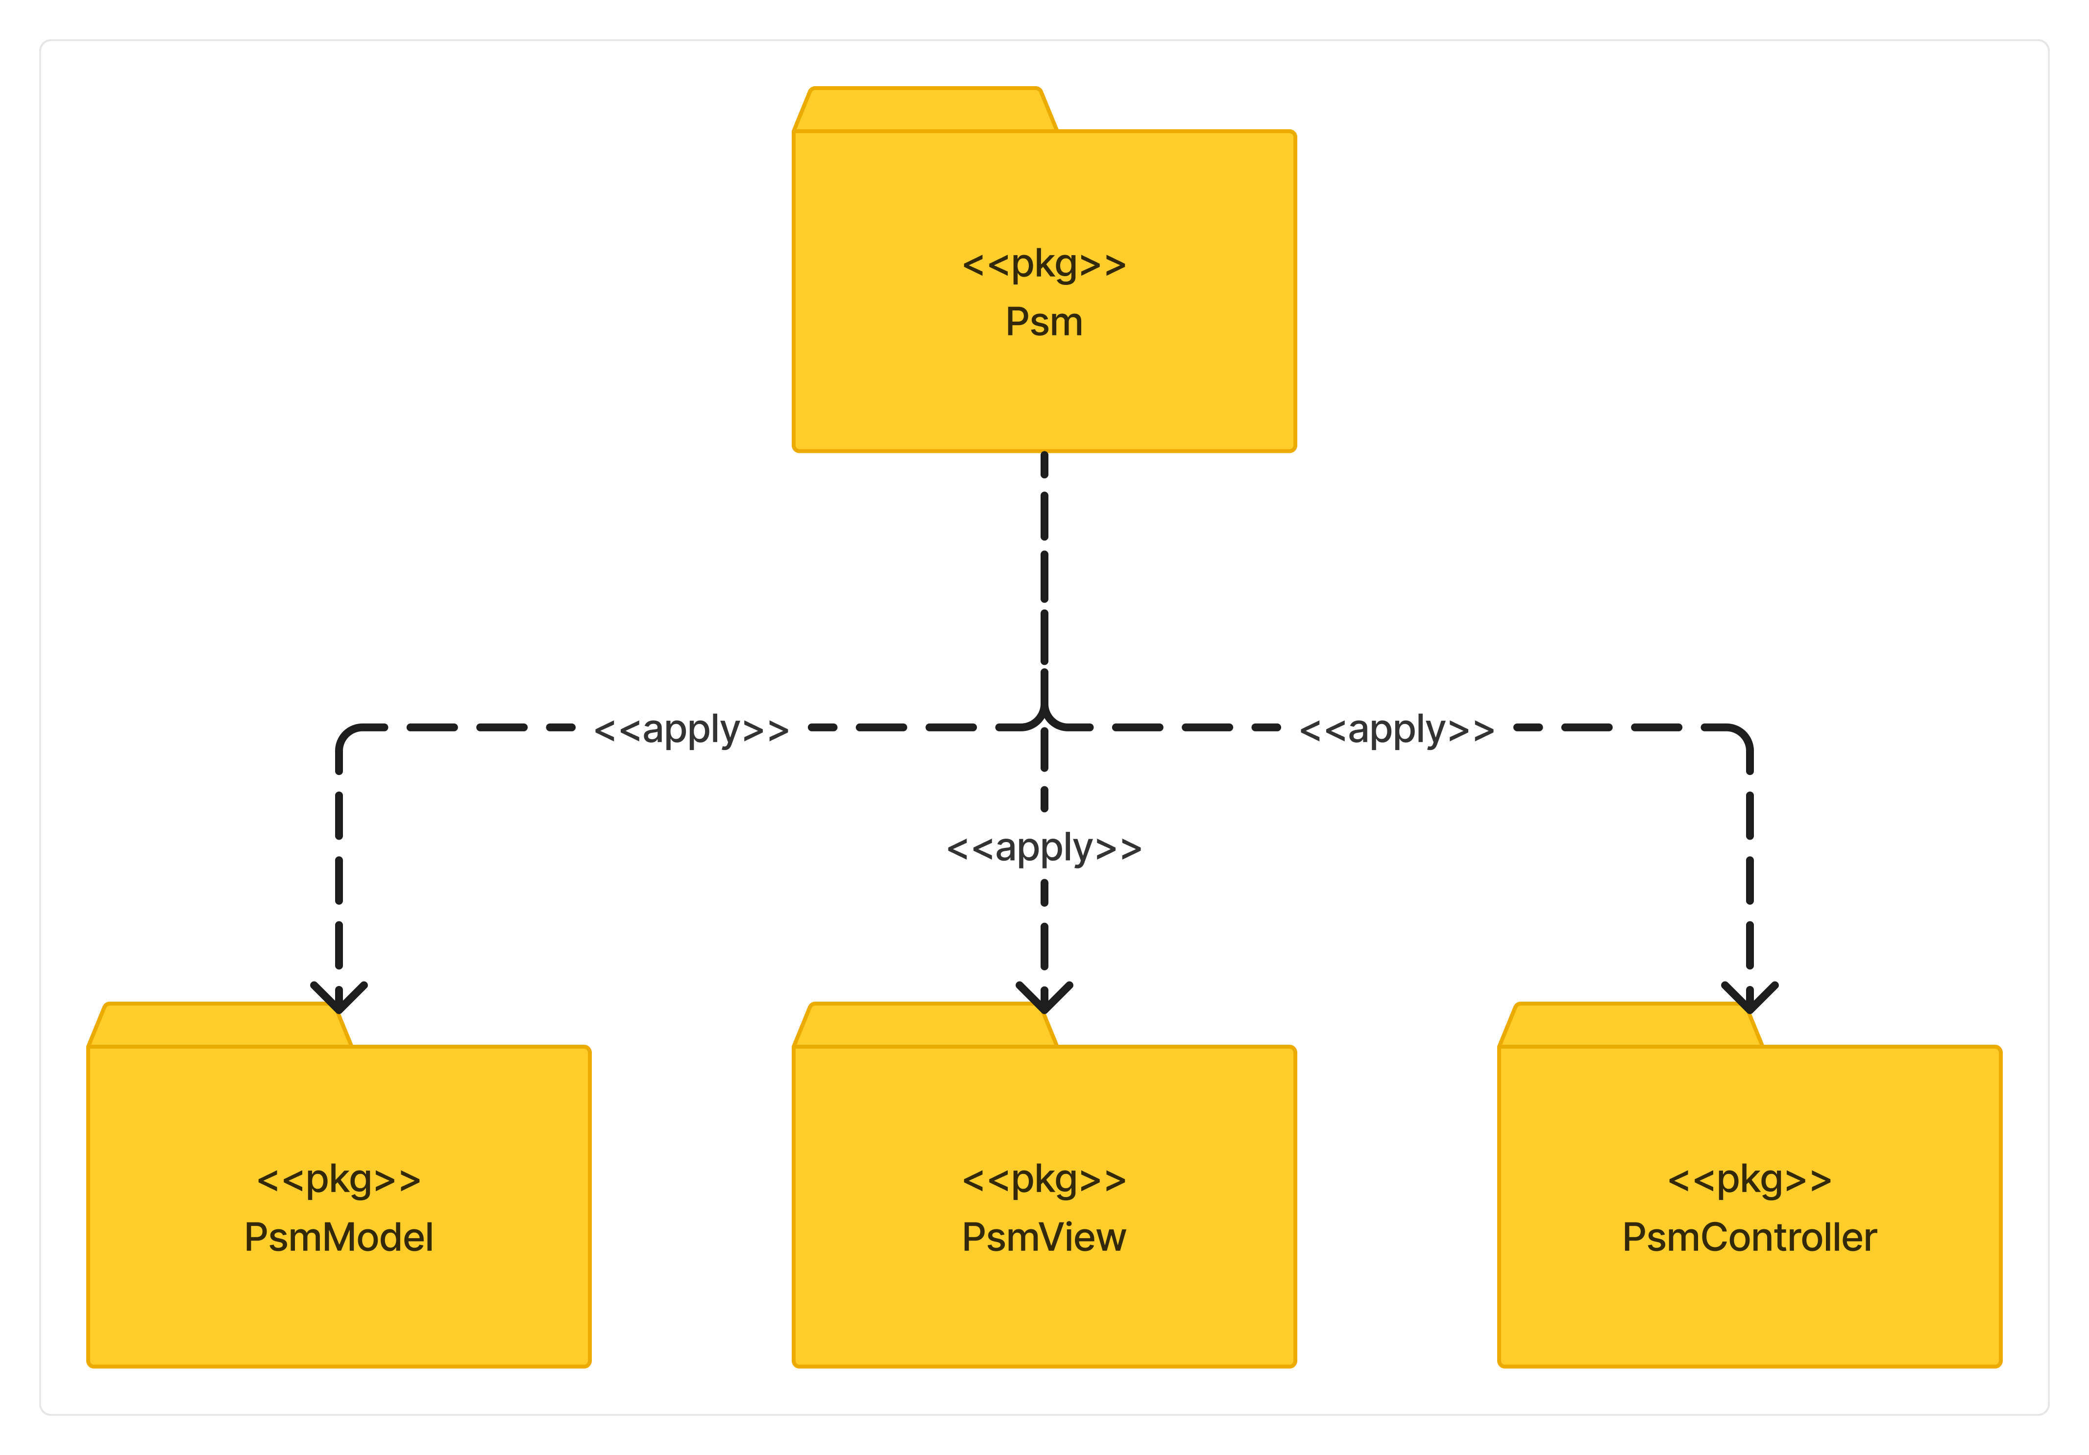

What should be the PSM profile looks like

* Splitting and expanding the conceptual model result
  + What are the class for PSM profile.
    - The reason why they are chosen to be included in PSM profile.
* MVC separated package.
  + Continuing the separation of concern
  + Packages contain core + technology-related profile
  + Class + Association relationship
    - Helping the connection between classes within and across profile
* Briefly introduce the explanatory subsections below

#### PSM MVC-Model Package

*Only exclusively talk about why the profile being made like this; not how to use it. For that part, there will be a separate section about it.*

*Everything in “Core” package is only to conveniently provide parent classes to be inherited from; so it will not cover many platform-dependent classes and elements.*

Opening paragraph of PSM MVC-Model package

* What is this package.
* The purpose of having this package
* The brief introduction of what is inside this package.

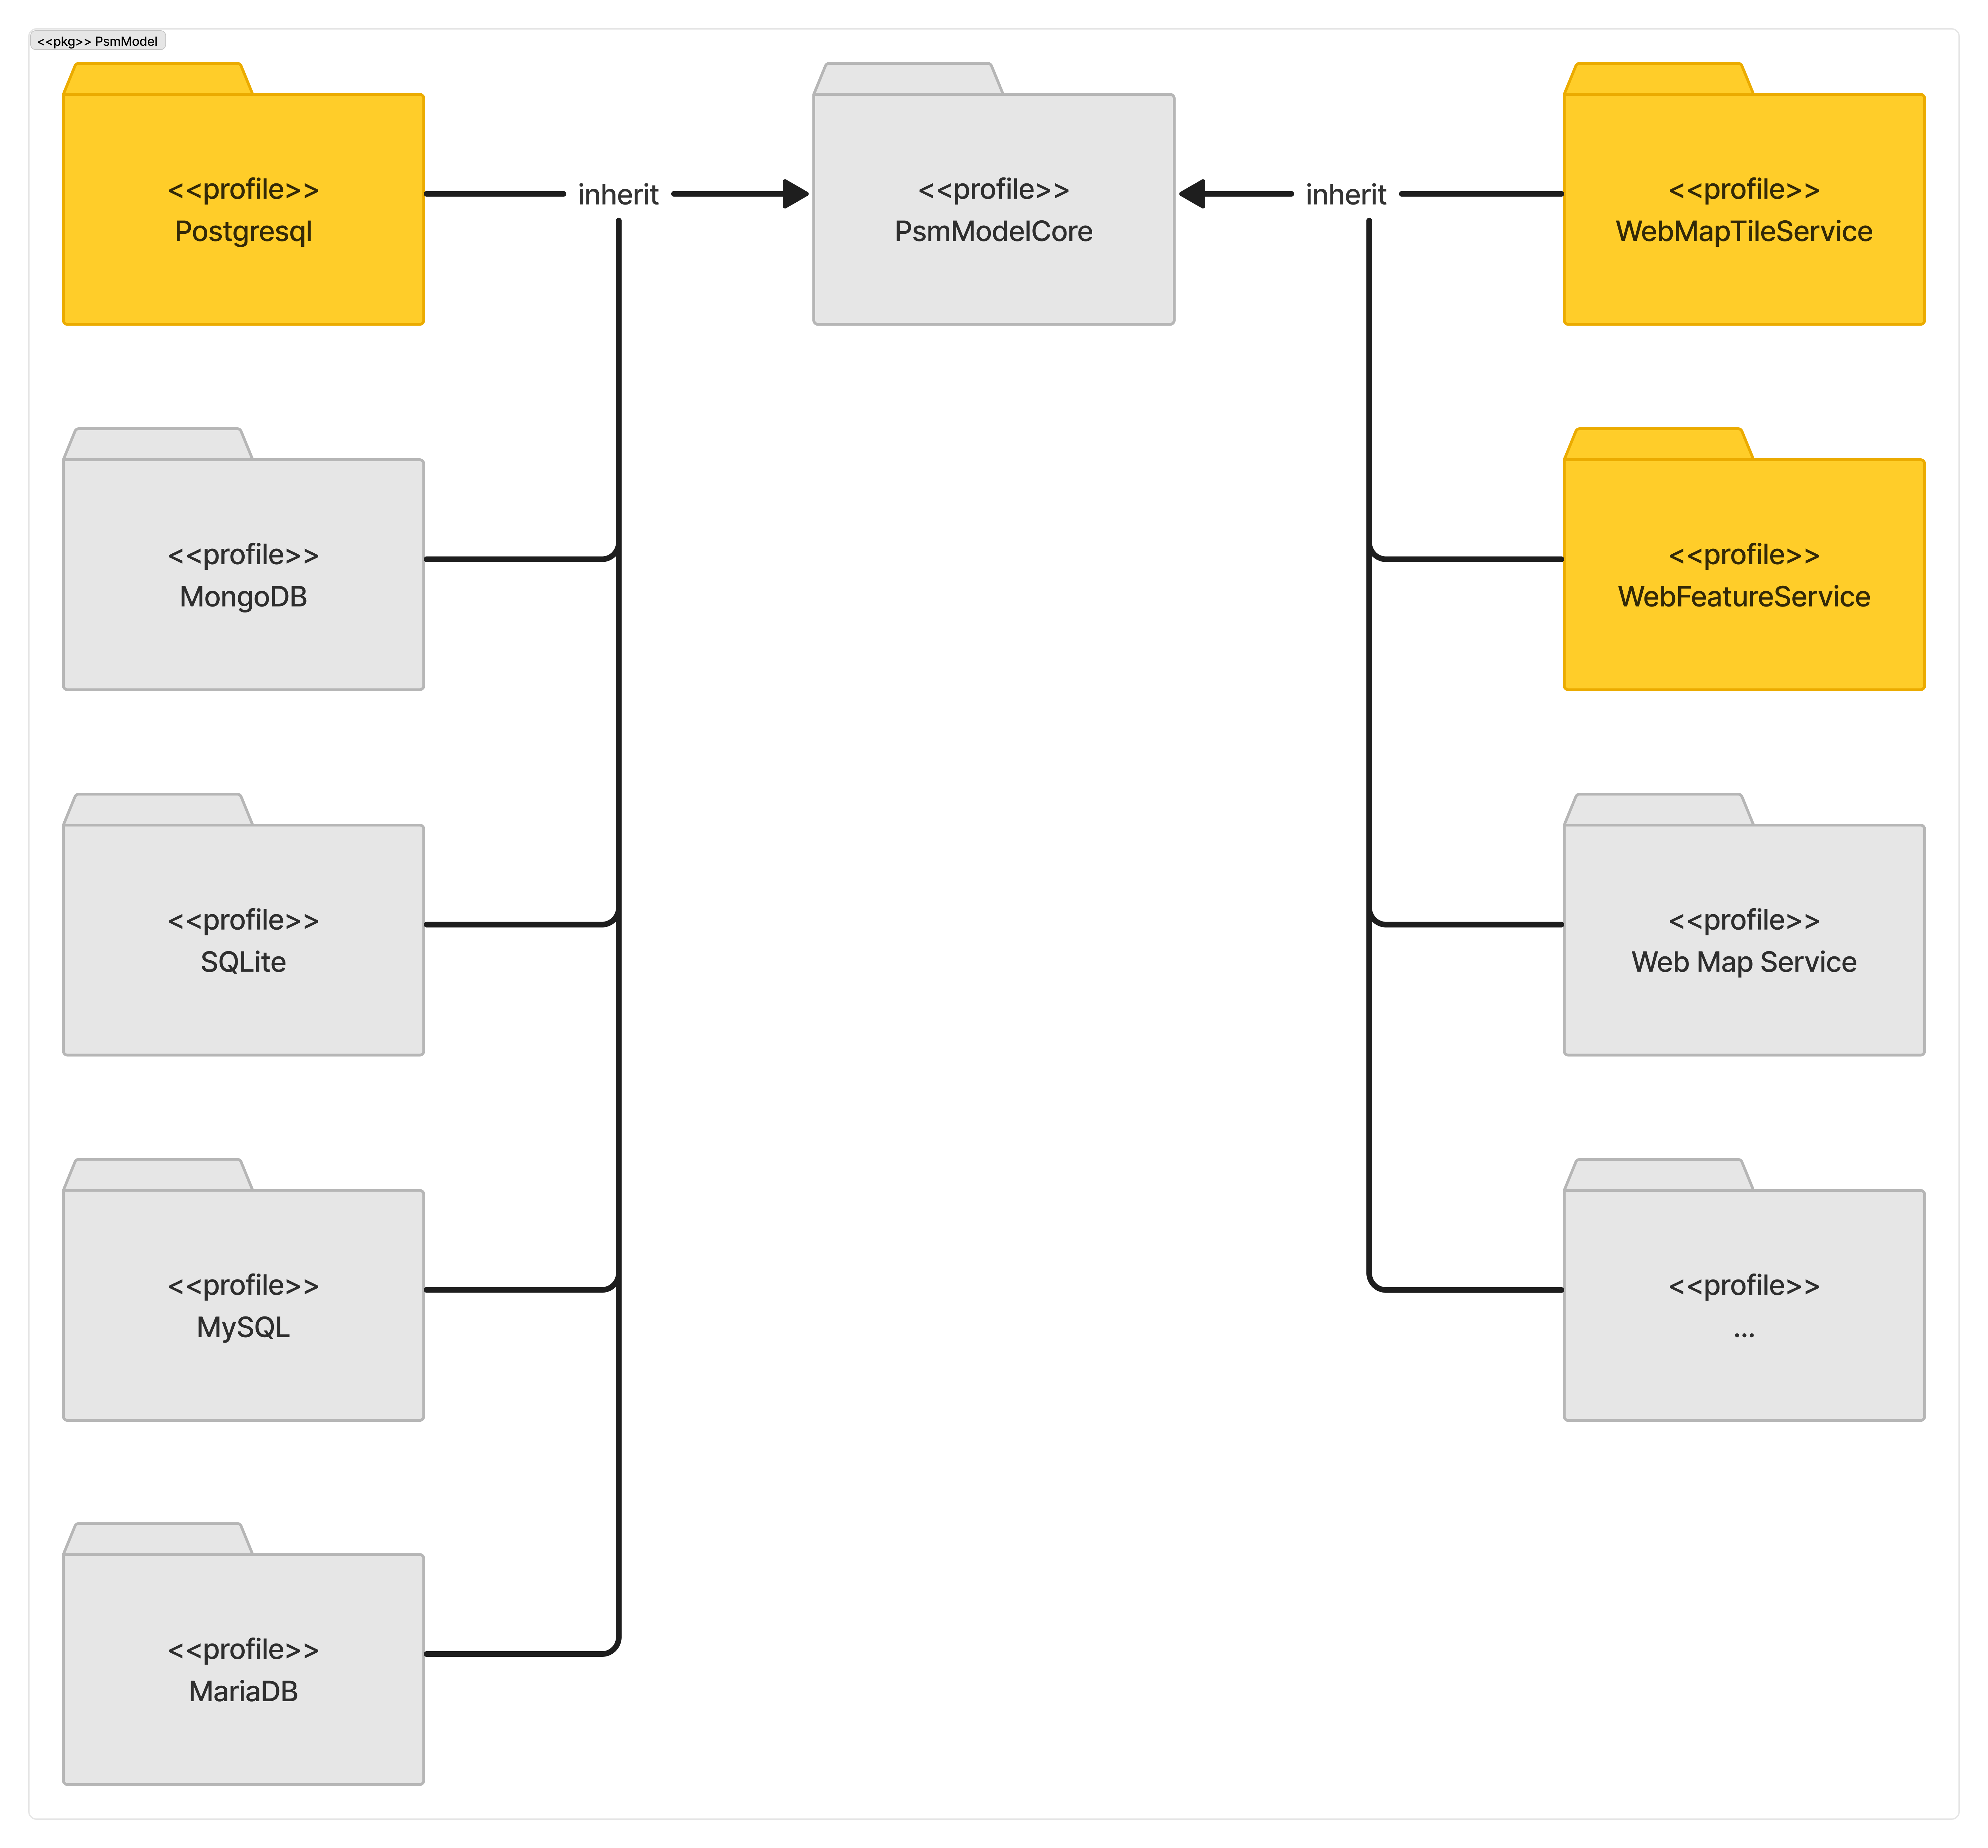

Opening paragraph of Postgresql

* What is this profile.
* The purpose of having this profile.
  + only to conveniently provide parent classes to be inherited from; so it will not cover many platform-dependent classes and elements
* The brief introduction of what is inside this profile.

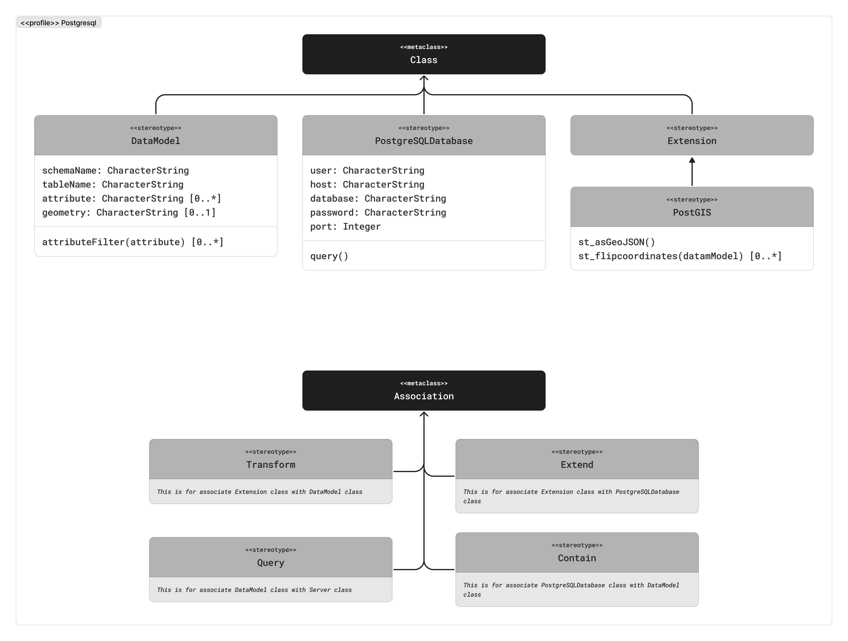

Overview explanation.

* What is inside this profile.
  + Classes
  + Associations
* The reason why

Explanation – Data Model

* What is it.
  + Definition
  + The reason why it is like that.
* The reason is it present here.
* The reason why it inherits a certain parent class if any
* Attributes
  + The reason why it is like that.
* Operations
  + The reason why it is like that.

Explanation – PostgreSQL Database

* What is it.
  + Definition
  + The reason why it is like that.
* The reason is it present here.
* The reason why it inherits a certain parent class if any
* Attributes
  + The reason why it is like that.
* Operations
  + The reason why it is like that.

Explanation – Extension

* What is it.
  + Definition
  + The reason why it is like that.
* The reason is it present here.
* The reason why it inherits a certain parent class if any
* Attributes
  + The reason why it is like that.
* Operations
  + The reason why it is like that.

Explanation – PostGIS

* What is it.
  + Definition
  + The reason why it is like that.
* The reason is it present here.
* The reason why it inherits a certain parent class if any
* Attributes
  + The reason why it is like that.
* Operations
  + The reason why it is like that.

Explanation – Query

* What is it.
  + Definition
  + The reason why it is like that.
* The reason is it present here.
* The reason why it inherits a certain parent class if any
* Attributes
  + The reason why it is like that.
* Operations
  + The reason why it is like that.

Explanation – Extend

* What is it.
  + Definition
  + The reason why it is like that.
* The reason is it present here.
* The reason why it inherits a certain parent class if any
* Attributes
  + The reason why it is like that.
* Operations
  + The reason why it is like that.

Explanation – Contain

* What is it.
  + Definition
  + The reason why it is like that.
* The reason is it present here.
* The reason why it inherits a certain parent class if any
* Attributes
  + The reason why it is like that.
* Operations
  + The reason why it is like that.

Explanation – Transform

* What is it.
  + Definition
  + The reason why it is like that.
* The reason is it present here.
* The reason why it inherits a certain parent class if any
* Attributes
  + The reason why it is like that.
* Operations
  + The reason why it is like that.

Opening paragraph of Web Feature Service

* What is this profile.
* The purpose of having this profile.
  + only to conveniently provide parent classes to be inherited from; so it will not cover many platform-dependent classes and elements
* The brief introduction of what is inside this profile.

Opening paragraph of Web Map Tile Service

* What is this profile.
* The purpose of having this profile.
  + only to conveniently provide parent classes to be inherited from; so it will not cover many platform-dependent classes and elements
* The brief introduction of what is inside this profile.

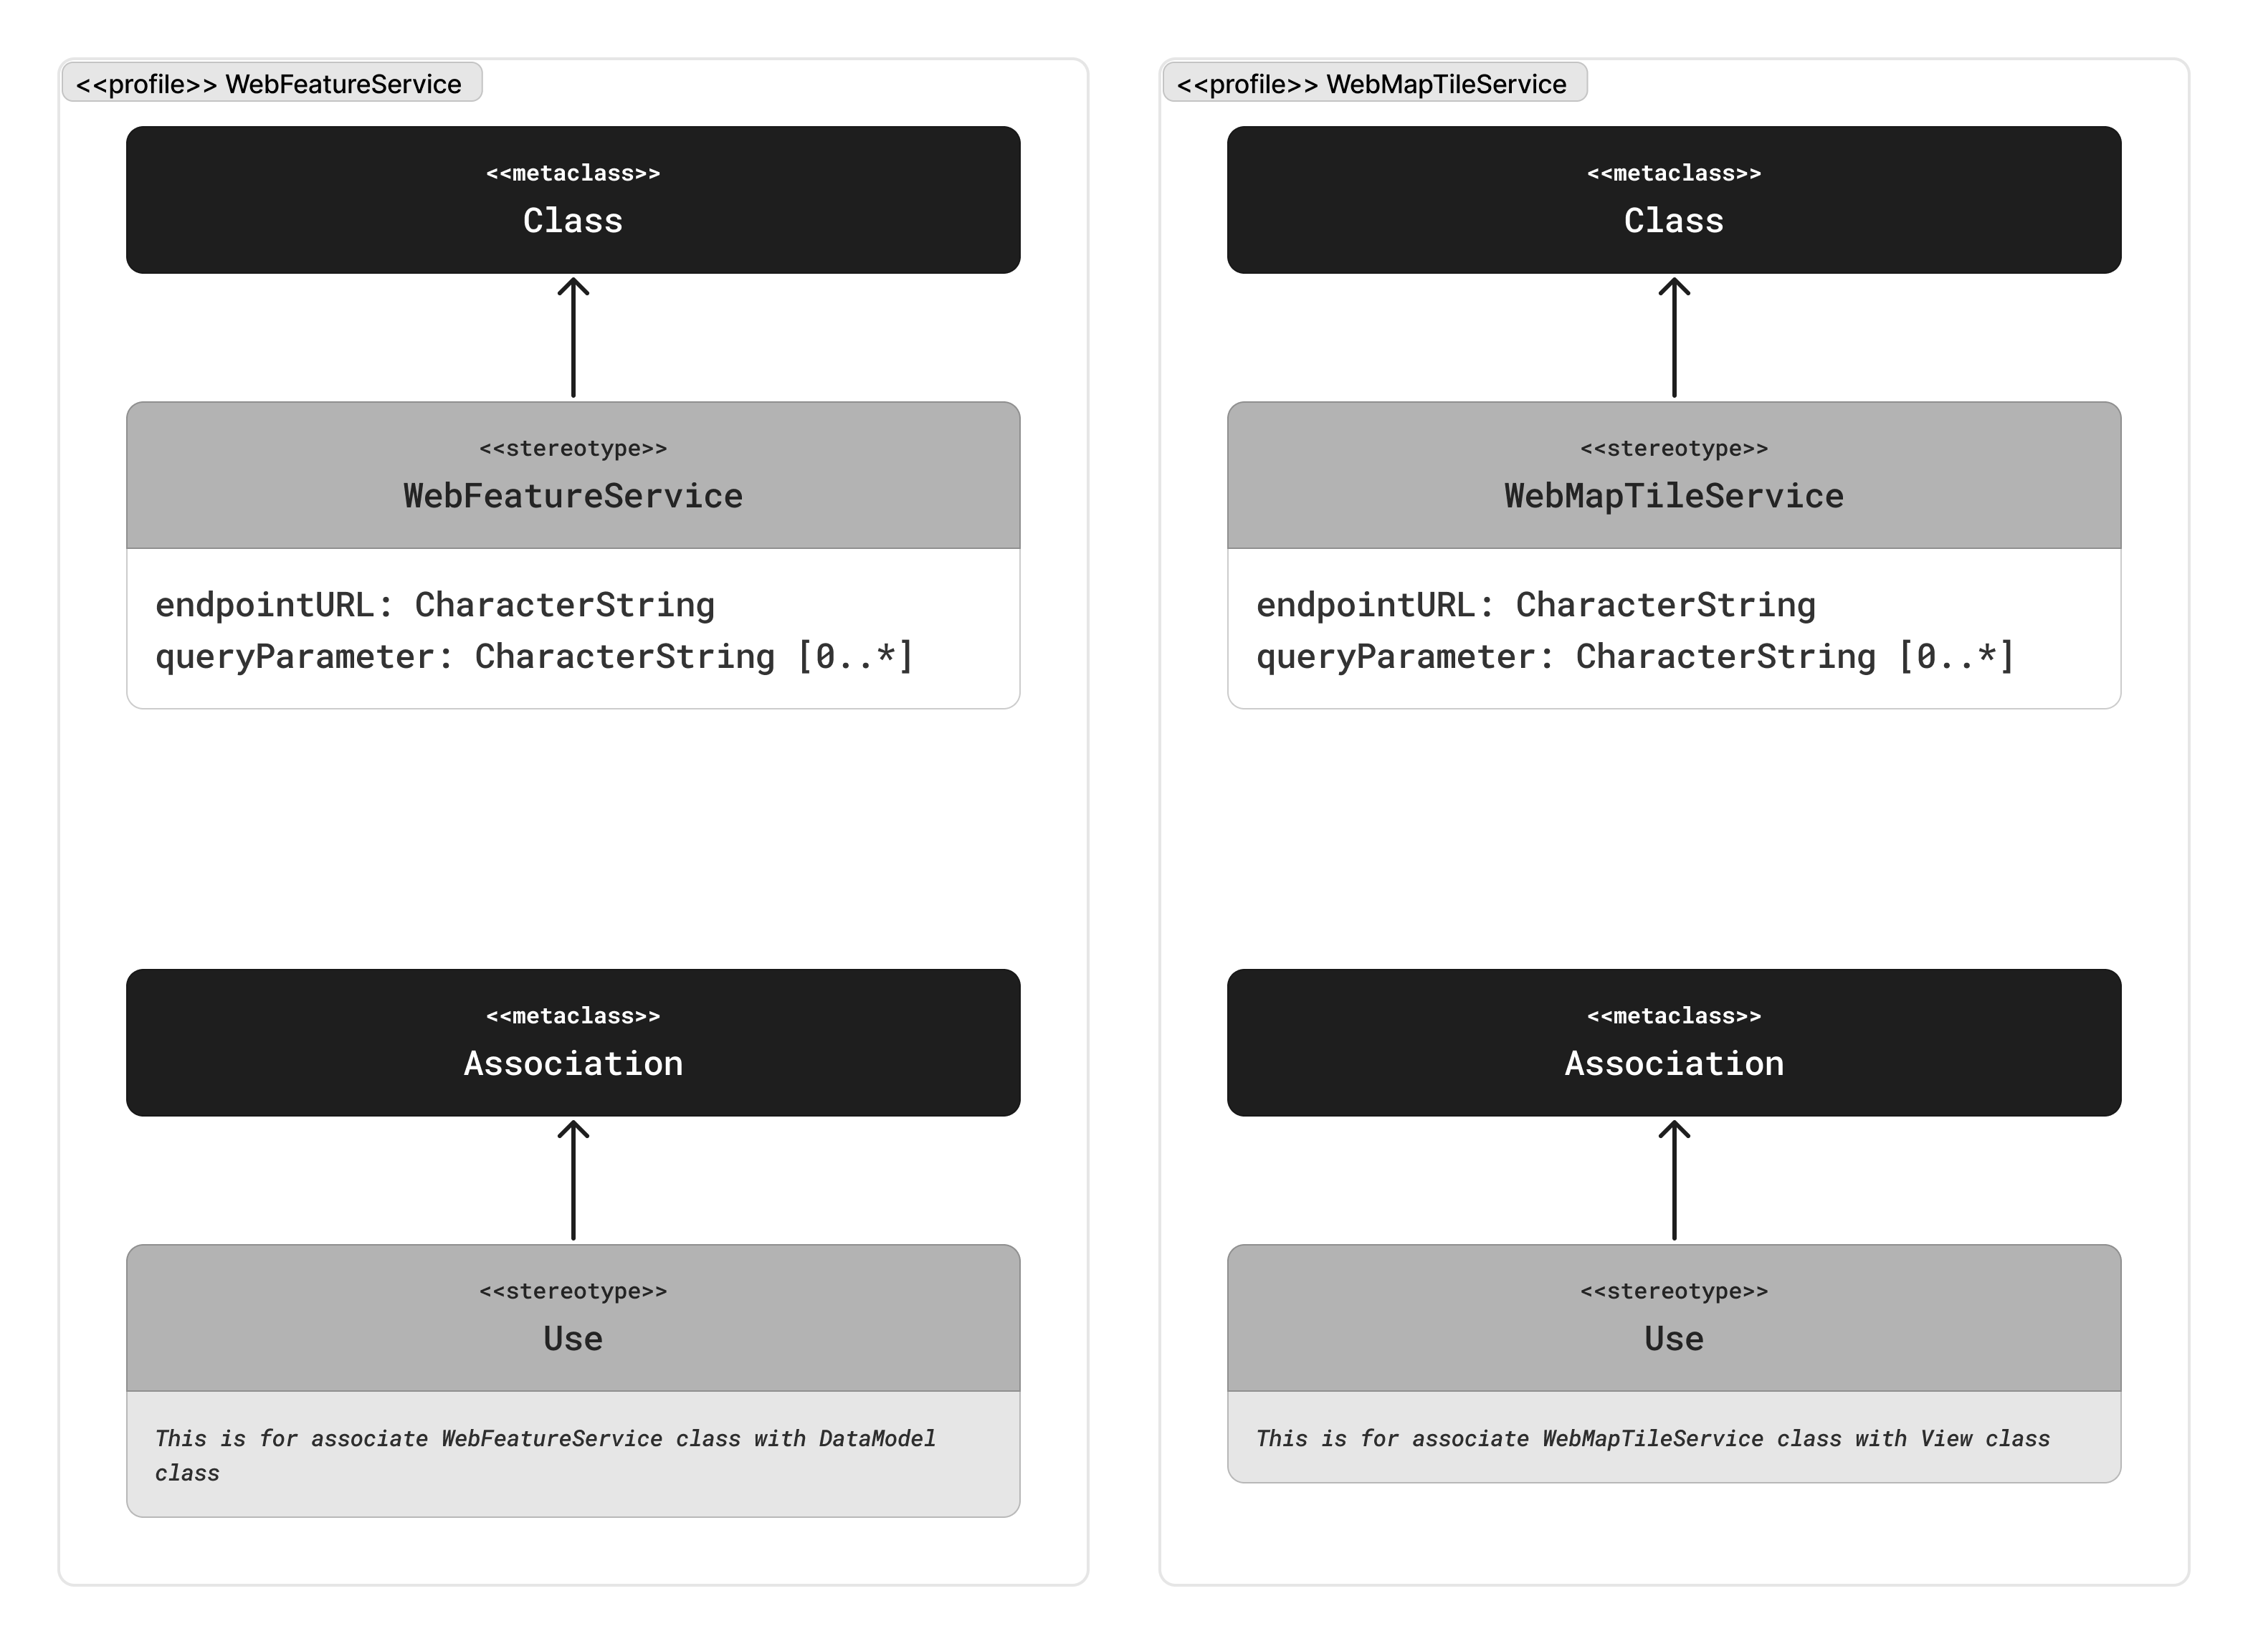

### WFS

Overview explanation.

* What is inside this profile.
  + Classes
  + Associations
* The reason why

Explanation – Web Feature Service

* What is it.
  + Definition
  + The reason why it is like that.
* The reason is it present here.
* The reason why it inherits a certain parent class if any
* Attributes
  + The reason why it is like that.
* Operations
  + The reason why it is like that.

Explanation – Use

* What is it.
  + Definition
  + The reason why it is like that.
* The reason is it present here.
* The reason why it inherits a certain parent class if any
* Attributes
  + The reason why it is like that.
* Operations
  + The reason why it is like that.

### WMTS

Overview explanation.

* What is inside this profile.
  + Classes
  + Associations
* The reason why

Explanation – Web Feature Service

* What is it.
  + Definition
  + The reason why it is like that.
* The reason is it present here.
* The reason why it inherits a certain parent class if any
* Attributes
  + The reason why it is like that.
* Operations
  + The reason why it is like that.

Explanation – Use

* What is it.
  + Definition
  + The reason why it is like that.
* The reason is it present here.
* The reason why it inherits a certain parent class if any
* Attributes
  + The reason why it is like that.
* Operations
  + The reason why it is like that.

#### PSM MVC-View Package

*Only exclusively talk about why the profile being made like this; not how to use it. For that part, there will be a separate section about it.*

*Everything in “Core” package is only to conveniently provide parent classes to be inherited from; so it will not cover many platform-dependent classes and elements.*

Opening paragraph of PSM MVC-View package

* What is this package.
* The purpose of having this package
* The brief introduction of what is inside this package.

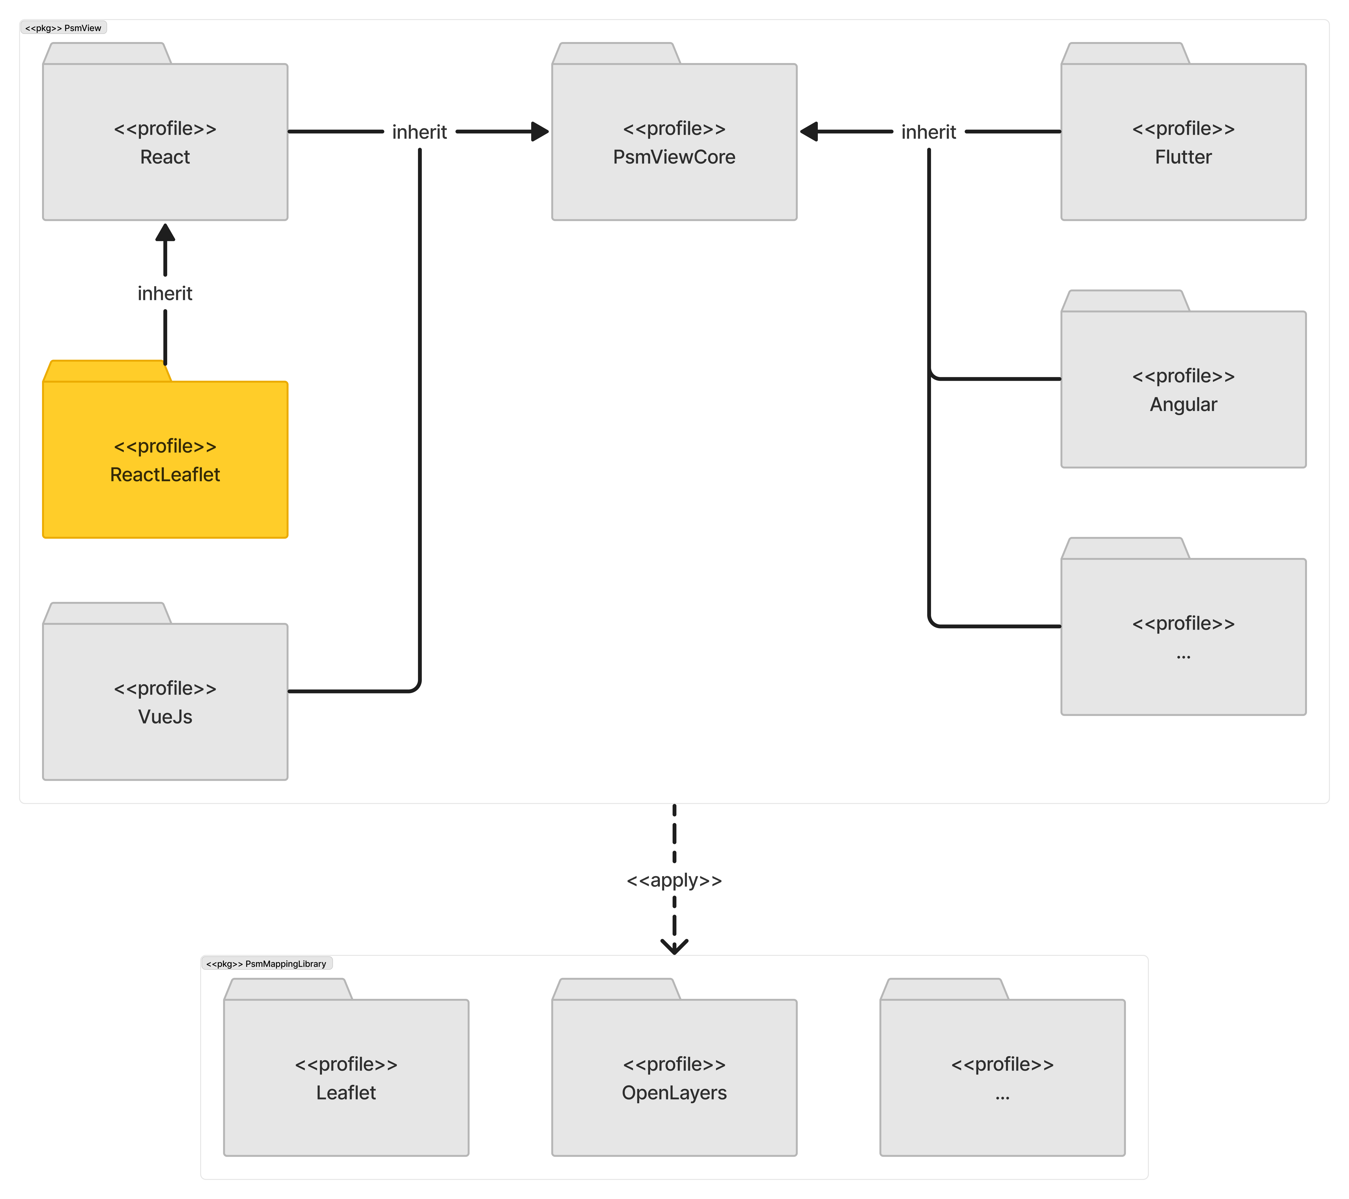

Opening paragraph of React Leaflet

* What is this profile.
* The purpose of having this profile.
  + only to conveniently provide parent classes to be inherited from; so it will not cover many platform-dependent classes and elements
* The brief introduction of what is inside this profile.

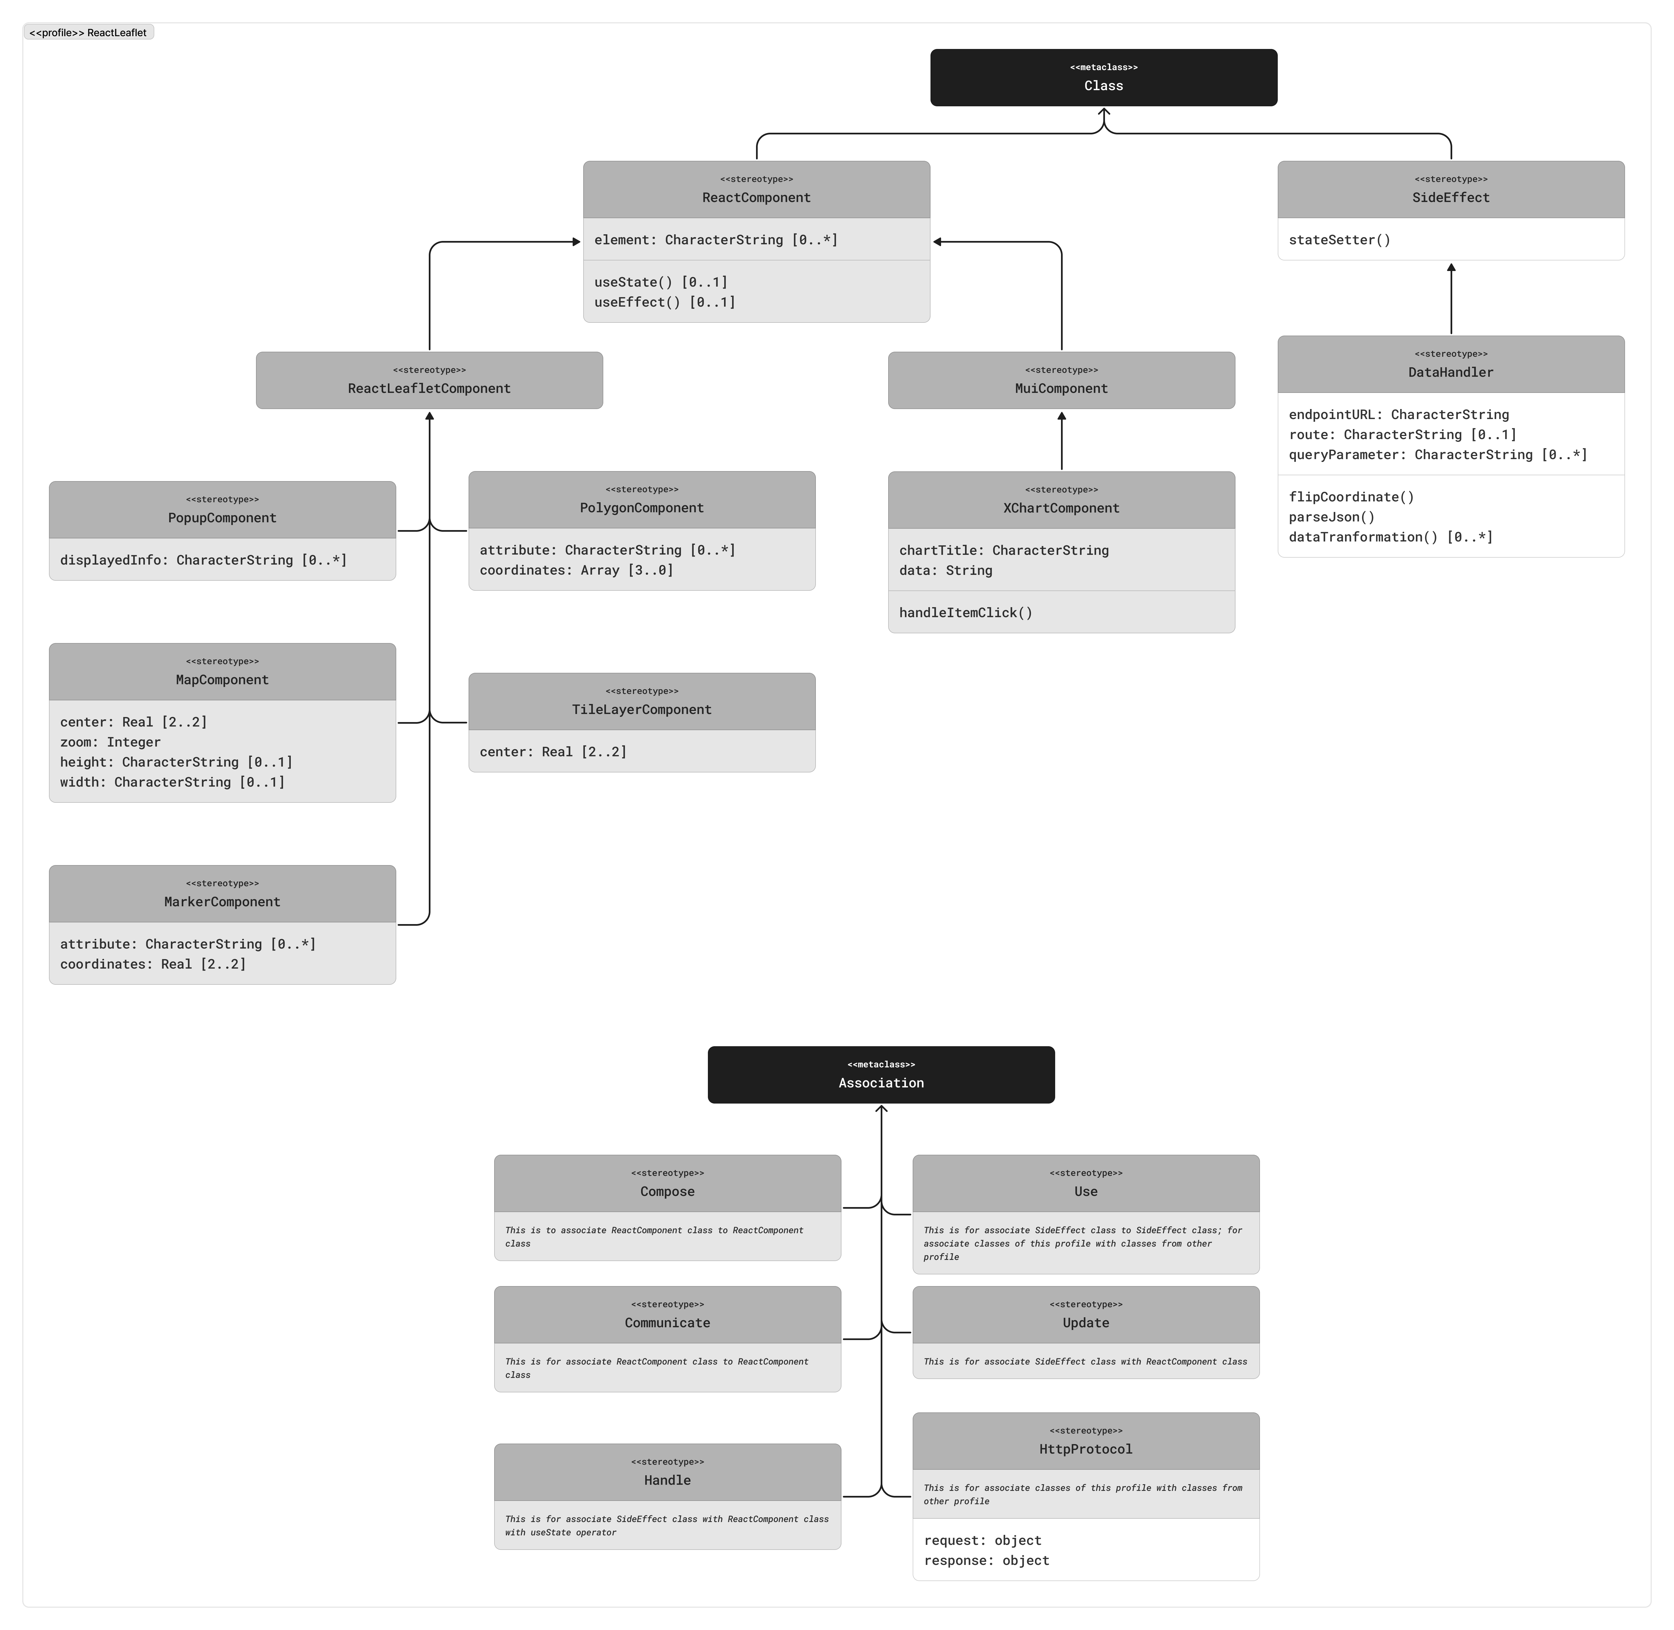

Overview explanation.

* What is inside this profile.
  + Classes
  + Associations
* The reason why

Explanation – …

* What is it.
  + Definition
  + The reason why it is like that.
* The reason is it present here.
* The reason why it inherits a certain parent class if any
* Attributes
  + The reason why it is like that.
* Operations
  + The reason why it is like that.

#### PSM MVC-Controller Package

*Only exclusively talk about why the profile being made like this; not how to use it. For that part, there will be a separate section about it.*

*Everything in “Core” package is only to conveniently provide parent classes to be inherited from; so it will not cover many platform-dependent classes and elements.*

Opening paragraph of PSM MVC-Controller package

* What is this package.
* The purpose of having this package
* The brief introduction of what is inside this package.

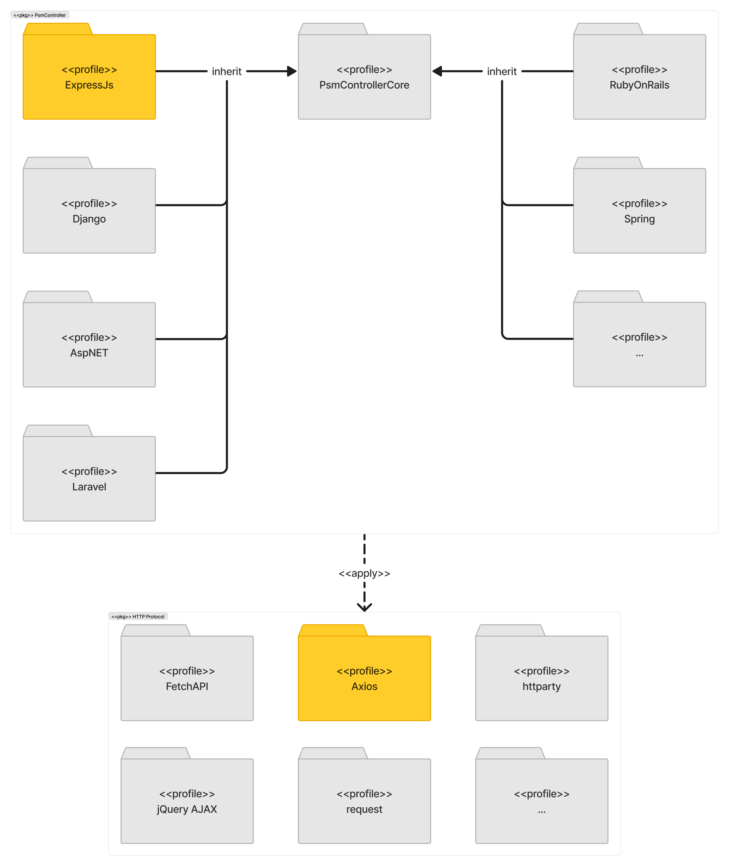

Opening paragraph of Express.js

* What is this profile.
* The purpose of having this profile.
  + only to conveniently provide parent classes to be inherited from; so it will not cover many platform-dependent classes and elements
* The brief introduction of what is inside this profile.

Overview explanation.

* What is inside this profile.
  + Classes
  + Associations
* The reason why

Explanation – …

* What is it.
  + Definition
  + The reason why it is like that.
* The reason is it present here.
* The reason why it inherits a certain parent class if any
* Attributes
  + The reason why it is like that.
* Operations
  + The reason why it is like that.

Opening paragraph of Axios

* What is this profile.
* The purpose of having this profile.
  + only to conveniently provide parent classes to be inherited from; so it will not cover many platform-dependent classes and elements
* The brief introduction of what is inside this profile.

Overview explanation.

* What is inside this profile.
  + Classes
  + Associations
* The reason why

Explanation – …

* What is it.
  + Definition
  + The reason why it is like that.
* The reason is it present here.
* The reason why it inherits a certain parent class if any
* Attributes
  + The reason why it is like that.
* Operations
  + The reason why it is like that.

## MDA Demonstration (not yet structured)

Opening paragraph of MDA demonstration

* User target: designer, developer
  + The reason why those users
  + What the users do by knowing this step
* What the step is doing
* What the purpose
* Expected final result

### PIM Instantiation (not yet structured)

Opening paragraph of PIM instantiation

* What the step is doing
  + Developing a PIM of web
* What the purpose
* Briefly introduce potential use of this to all targeted users
  + Which will be detailed in later demonstration section

### PIM to PSM Transformation Development (not yet structured)

Opening paragraph of PIM to PSM transformation development

* What the step is doing
  + Transformation from PIM to PSM using model transformation
  + In this phase, PIM instantiation is assumed to be created
* What the purpose
* Briefly introduce potential use of this to all targeted users
  + Which will be detailed in later demonstration section

Transformation rules

1. …
2. When a PIM stereotype of any MVC pattern is being chosen, user is to compile all available PSM profiles that is “fall within the category of” the chosen stereotype of the same MVC pattern.
   1. Example: when choosing “Local Database” …
   2. Currently depends on user’s discretion and judgement.
   3. Recommendation: this can be automated later.
   4. Later in the draft: I need to demonstrate in my choice

* … *more* *will be discovered during demonstration …*

*What to talk about:*

* *It is assumed the PIM instantiation has been created*
* *The mechanism of how PIM translates to PSM*
  1. *PIM is converted to JSON*
     1. *~~What is JSON~~*
     2. *Geonovum UML2JSON encoding*
        1. *(Introduce more early) How PIM class is converted to PSM class*
           1. *How PIM stereotype choice limit the PSM profile to use*

*Not applied, but discussed*

*Possibly using if-true then add-every—compliant-available-choice-to-list condition; then becomes multiple choice for user*

*Managed in transformation rules*

*Only limited to available profiles*

* + - * 1. *How PSM MVC class choice limit the other PSM MVC class to use*

*Not applied, but discussed*

* 1. *How PIM-JSON is transformed to PSM-JSON*
     1. *Awesome JSON-to-JSON library*
* *List all assumptions made in making this thesis (for discussion?)*
  1. *There are many frameworks* 
     1. *Not applied, but discussed*
* *How model validation works*
  + *How the intermediary interface to complete the model works*
    - *Current preferred way: JS object definition for empty JSON*

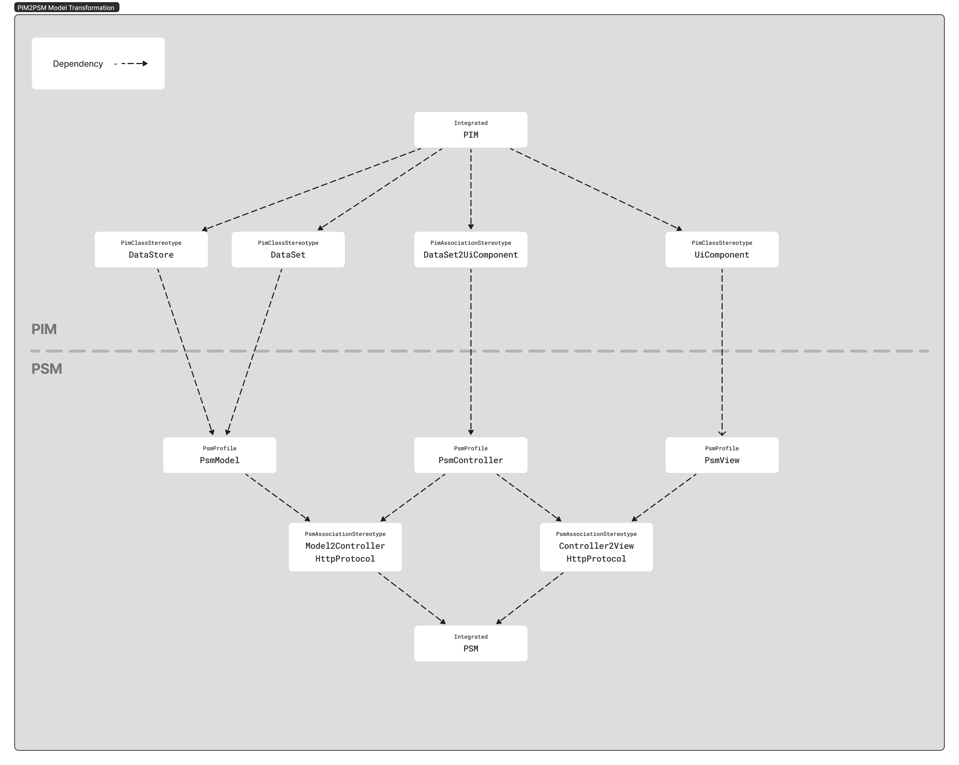

### PSM to Code Transformation Development (not yet structured)

Transformation rules

1. Object-oriented paradigm is to reinforced

* … *more* *will be discovered during demonstration …*

## MDA Demonstration (not yet structured based on the user types)

Creating PIM instance

* Step by step

Transforming to PIM-JSON

* Step by step
* How model validation works

Model transformation: PIM-JSON to PSM-JSON

* Step by step

Model transformation: PSM-JSON to Code

* Step by step
* How model validation works
  + How the intermediary interface to complete the model works
    - Current preferred way:
      * JS object definition
      * Deliberate prompting

### XXXXXXXXXXXXXXXXXX

# References

Hossain, M. I. (2023). Software Development Life Cycle (SDLC) Methodologies for Information Systems Project Management. *IJFMR - International Journal For Multidisciplinary Research*, *5*(5). https://doi.org/10.36948/IJFMR.2023.V05I05.6223

Ameller, D., Burgués, X., Collell, O., Costal, D., Franch, X., & Papazoglou, M. P. (2015). Development of service-oriented architectures using model-driven development: A mapping study. *Information and Software Technology*, *62*(1), 42–66. https://doi.org/10.1016/J.INFSOF.2015.02.006

Barry, C., & Lang, M. (2003). A comparison of ‘traditional’ and multimedia information systems development practices. *Information and Software Technology*, *45*(4), 217–227. https://doi.org/10.1016/S0950-5849(02)00207-0

Betari, O., Filali, S., Azzaoui, A., & Boubnad, M. A. (2018). Applying a Model Driven Architecture Approach: Transforming CIM to PIM Using UML. *International Journal of Online and Biomedical Engineering (IJOE)*, *14*(09), 170–181. https://doi.org/10.3991/IJOE.V14I09.9137

Blanc, N., Cannata, M., Collombin, M., Ertz, O., Giuliani, G., & Ingensand, J. (2022). OGC API State of Play - A Practical Testbed for The National Spatial Data Infrastructure in Switzerland. *International Archives of the Photogrammetry, Remote Sensing and Spatial Information Sciences - ISPRS Archives*, *48*(4/W1-2022), 59–65. https://doi.org/10.5194/ISPRS-ARCHIVES-XLVIII-4-W1-2022-59-2022

Conallen, J. (1999). *Building Web applications with UML*.

Distante, D., Pedone, P., Rossi, G., & Canfora, G. (2007). Model-driven development of Web applications with UWA, MVC and JavaServer faces. *Lecture Notes in Computer Science (Including Subseries Lecture Notes in Artificial Intelligence and Lecture Notes in Bioinformatics)*, *4607 LNCS*, 457–472. https://doi.org/10.1007/978-3-540-73597-7_38/COVER

Kamatchi, Iyer, J., & Singh, S. (2013). Software Engineering:Web Development Life Cycle. *International Journal of Engineering Research & Technology*, *2*(3). https://doi.org/10.17577/IJERTV2IS3438

Duke, D. J., Evans, A. S., Clark, T., Clark, T., & Evans, A. (1997). *Foundations of the Unified Modeling Language*. 14–15. https://doi.org/10.14236/EWIC/FA1997.6

Elleuch, N., Khalfallah, A., & Ben Ahmed, S. (2007). Software architecture in model driven architecture. *ISCIII’07: 3rd International Symposium on Computational Intelligence and Intelligent Informatics; Proceedings*, 219–223. https://doi.org/10.1109/ISCIII.2007.367392

Fielding, R. T., Taylor, R. N., Erenkrantz, J. R., Gorlick, M. M., Whitehead, J., Khare, R., & Oreizy, P. (2017). Reflections on the REST architectural style and “principled design of the modern web architecture” (impact paper award. *Proceedings of the ACM SIGSOFT Symposium on the Foundations of Software Engineering*, *Part F130154*, 4–14. https://doi.org/10.1145/3106237.3121282

Gellersen, H. W., & Gaedke, M. (1999). Object-oriented Web application development. *IEEE Internet Computing*, *3*(1), 60–68. https://doi.org/10.1109/4236.747323

Giubergia, A., Riesco, D., Gil-Costa, V., & Printista, M. (2014). UML Profile for Mining Process: Supporting Modeling and Simulation Based on Metamodels of Activity Diagram. *Modelling and Simulation in Engineering*, *2014*(1), 974850. https://doi.org/10.1155/2014/974850

Gosala, B., Chowdhuri, S. R., Singh, J., Gupta, M., & Mishra, A. (2021). Automatic Classification of UML Class Diagrams Using Deep Learning Technique: Convolutional Neural Network. *Applied Sciences 2021, Vol. 11, Page 4267*, *11*(9), 4267. https://doi.org/10.3390/APP11094267

Jiang, S., & Mu, H. (2011). Design patterns in object oriented analysis and design. *ICSESS 2011 - Proceedings: 2011 IEEE 2nd International Conference on Software Engineering and Service Science*, 326–329. https://doi.org/10.1109/ICSESS.2011.5982229

Jovanović, M., Starčević, D., & Jovanović, Z. (2013). Languages for model-driven development of user  interfaces: Review of the state of the art. *Yugoslav Journal of Operations Research*, *23*(3), 327–341. https://doi.org/10.2298/YJOR121101007J

Ma, W.-M., & Chao, W. S. (2020). Structure-Behavior Coalescence Abstract State Machine for Metamodel-Based Language in Model-Driven Engineering. *IEEE Systems Journal*, *15*(3), 4105–4115. https://doi.org/10.1109/JSYST.2020.3027195

Malik, S., & Kim, D. H. (2017). A comparison of RESTful vs. SOAP web services in actuator networks. *International Conference on Ubiquitous and Future Networks, ICUFN*, 753–755. https://doi.org/10.1109/ICUFN.2017.7993893

Meliá, S., Gómez, J., & Koch, N. (2005). Improving web design methods with architecture modeling. *Lecture Notes in Computer Science*, *3590*, 53–64. https://doi.org/10.1007/11545163_6/COVER

OGC. (2023). *OGC API - Common - Part 1: Core*. https://docs.ogc.org/is/19-072/19-072.html

OMG. (2014). MDA Guide rev 2.0. In *OMG Document ormsc/2014-06-01*. https://www.omg.org/cgi-bin/doc?ormsc/14-06-01

OMG. (2017). *OMG®  Unified Modeling Language®  (OMG UML® )*. https://www.omg.org/spec/UML/20161101/PrimitiveTypes.xmi

Peña-Ortiz, R., Gil, J. A., Sahuquillo, J., & Pont, A. (2013). Analyzing web server performance under dynamic user workloads. *Computer Communications*, *36*(4), 386–395. https://doi.org/10.1016/J.COMCOM.2012.11.005

Pop, D. P., & Altar, A. (2014). Designing an MVC Model for Rapid Web Application Development. *Procedia Engineering*, *69*, 1172–1179. https://doi.org/10.1016/J.PROENG.2014.03.106

Rauf, I., Ruokonen, A., Systa, T., & Porres, I. (2010). Modeling a composite RESTful web service with UML. *ACM International Conference Proceeding Series*, 253–260. https://doi.org/10.1145/1842752.1842801

Rivero, J. M., Grigera, J., Rossi, G., Robles Luna, E., & Koch, N. (2012). Towards Agile Model-Driven Web Engineering. *Lecture Notes in Business Information Processing*, *107 LNBIP*, 142–155. https://doi.org/10.1007/978-3-642-29749-6_10

Rodríguez, C., Baez, M., Daniel, F., Casati, F., Trabucco, J. C., Canali, L., & Percannella, G. (2016). REST APIs: A large-scale analysis of compliance with principles and best practices. *Lecture Notes in Computer Science (Including Subseries Lecture Notes in Artificial Intelligence and Lecture Notes in Bioinformatics)*, *9671*, 21–39. https://doi.org/10.1007/978-3-319-38791-8_2/FIGURES/4

Royce, W. W. (1970). MANAGING THE DEVELOPMENT OF LARGE SOFTWARE SYSTEMS. *Proceedings of the 9th International Conference on Software Engineering*. https://doi.org/10.5555/41765.41801

Shcherban, S., Liang, P., Li, Z., & Yang, C. (2021). Multiclass Classification of Four Types of UML Diagrams from Images Using Deep Learning. *Proceedings of the International Conference on Software Engineering and Knowledge Engineering, SEKE*, *2021-July*, 57–62. https://doi.org/10.18293/SEKE2021-185

Singh, Y., & Sood, M. (2010). The Impact of the Computational Independent Model for Enterprise Information System Development. *International Journal of Computer Applications*, *11*(8), 975–8887.

Thomas, D. (2004). MDA: Revenge of the modelers or UML Utopia? *IEEE Software*, *21*(3), 15–17. https://doi.org/10.1109/MS.2004.1293067

Veenendaal, B. (2015). DEVELOPING A MAP USE MODEL FOR WEB MAPPING AND GIS. *The International Archives of the Photogrammetry, Remote Sensing and Spatial Information Sciences*, *XL-4-W7*(4W7), 31–34. https://doi.org/10.5194/ISPRSARCHIVES-XL-4-W7-31-2015

Whittle, J., Hutchinson, J., & Rouncefield, M. (2014). The state of practice in model-driven engineering. *IEEE Software*, *31*(3), 79–85. https://doi.org/10.1109/MS.2013.65

Wimmer, M., Schauerhuber, A., Schwinger, W., & Kargl, H. (2006). On the Integration of Web Modeling Languages: Preliminary Results and Future Challenges. *7th International Conference on Web Engineering, Workshop Proceedings*, 255–269. https://repositum.tuwien.at/handle/20.500.12708/51838

Xiao, L., & Greer, D. (2009). Adaptive Agent Model: Software Adaptivity using an Agent-oriented Model-Driven Architecture. *Information and Software Technology*, *51*(1), 109–137. https://doi.org/10.1016/J.INFSOF.2008.02.002